**MIDTERM_ADTA5900_5750_501_assignment_2024_FALL_PART_I_II.pdf**

**Yog Chaudhary**

11727095

ADTA 5750 Applied Natural Language Processing

Professor: Dr. Thuan L Nguyen

University of North Texas **Oct 16, 2024**

**2. PART I: Short Questions and Answers (25 Points**)

Answer the following questions with short answers:

**1. A dialogue/conversation can be represented and visualized with a state machine: TRUE or FALSE?**

ANSWER: **TRUE**

**2. If so (from QUESTION 1), what concept(s) of Dialogflow CX can be matched with a state of the above state machine?**

ANSWER: In Dialogflow CX, various concepts correspond to states in a state machine, facilitating structured conversations are following.

* **Pages** represent specific interaction states, defining user engagement at each moment.
* **Flows** are collections of pages that organize the overall dialogue, guiding different conversation paths.
* **Intents** capture user intentions and trigger transitions between pages based on input. Events are occurrences that can initiate page transitions, reflecting context changes.
* **Transitions** determine when the conversation shifts from one page to another, while parameters store relevant data to maintain context. These elements help developers effectively manage and streamline the conversational flow.

**3. Provide an example of the pair: ENTITY TYPE – LIST OF ENTITY ENTRIES**

ANSWER: For example, of an Entity Type paired with its corresponding List of Entity Entries in the context supposed like of a **Travel Mode**: Train, Airplane, Bus, Car, Bicycle, Boat. Motorcycle. Walking, and Subway. It categorizes various means of transportation that a user might consider when discussing travel options.

**4. Provide an example of mapping entities**

ANSWER: We provided our concepts within a conversion: Travel Booking is entity Types, and list of Entity entries for the example of mapping entities as following tables.

|  |  |  |
| --- | --- | --- |
| **User Inputs** | **Mapping Entity Types** | **Mapped Entity Entry** |
| I want to fly to New York | Travel Destination | New York |
| Can you book me a hotel in Chicago? | Travel Destination | Chicago |
| I'm considering a trip to New Mexico. | Travel Destination | New Mexico |
| Let's visit Nepal this summer | Travel Destination | Nepal |

This mapping allows to understand the user’s intent and respond as providing travel options, hotel booking, and travel information related to Nepal or Mew Mexico.

**5. Describe different types of state handlers**

ANSWER: Different types of state handlers are following:

**Page State Handlers**: Each page in Dialogflow CX represents a specific state in the conversation. They function used Page state handlers manage how the bot acts when a user enters or leaves a page. They set prompts, handle user responses, and guide the conversation. These handlers help the conversation move smoothly from one part to another, keeping everything organized and clear for the user.

**Transition Handlers:** Transition handlers set the rules for moving the conversation from one page to another. They decide which events or user inputs (like intents) will trigger the switch between pages, helping the chatbot move smoothly between different steps based on what the user says.

**Input State Handlers:** These handlers manage the inputs the bot gets from users. Input state handlers determine how the bot understands and processes user inputs (like text, voice, or button clicks) and how it responds based on the user’s intent.

**Event Handlers:** Event handlers respond to special events during the conversation, like timeouts, system messages, or external triggers. They handle unexpected situations, remind the user, or move the conversation to a different page based on outside factors or conditions.

**Parameter Handlers:** These handlers manage the parameters collected during the conversation. They used function on it These handlers manage the parameters collected during the conversation.

**Error Handlers**: Error handlers manage situations when something goes wrong in the conversation, such as unrecognized inputs or system errors. They help the chatbot recover gracefully, provide helpful error messages, or prompt the user to try again.

**Summary of State Handlers:**

* Intent Routes: Match user input and transition based on intents.
* Condition Routes: Transition based on logical conditions or parameters.
* Event Handlers: Manage transitions triggered by events like no input.
* Parameter Handlers: Collect and validate required user data.
* Entry Fulfillment Handlers: Define actions or responses when a page is activated.
* Fallback Handlers: Handle unmatched or unclear user inputs.
* Transition Handlers: Move the conversation between different pages or flows.

These state handlers enable flexible and dynamic control of conversation flow, ensuring that the virtual agent can manage various situations smoothly.

**6. What is a route?**

ANSWER: In Dialogflow CX, a route is the conversion from one page state to another based on certain conditions. Routs determines the virtual agent transaction between different stages of the conversion, like as intent, a conditional or an event. Theses conversion flows smoothly and logically. They are main three types of routs:

* Intent routes: Triggered when a specific user intent is recognized.
* Condition routes: Triggered when certain predefined conditions are met.
* Event routes: Triggered by specific events like no input or fallback situations.

**7. What is an event handler?**

ANSWER: An event handler in Dialogflow CX is a function that responds to specific events that occur during a conversation. Event handler helps manager can be situation by Re-prompting the user when no input is received. Handling fallback responses when the bot doesn’t understand the user. And triggering specific actions based on external conditions or events.

**8. If a route is applied to a flow and the current page of the flow is the Default Start Page, is the route in scope?**

ANSWER: Yes, if a route is applied to a flow and the current page of the flow is the Default Start Page, the route is considered in scope. In Dialogflow CX, routes attached to a flow are available to all the pages within that flow, including the Default Start Page. This means that if the conditions for the route (such as a specific intent, event, or condition) are met while the Default Start Page is active, the route will trigger and the conversation will proceed according to the defined transition.

**9. What routes can be evaluated?**

ANSWER: Routes can be evaluated In Dialogflow CX, three key routes guide the conversation flow: Intent Routes, which are triggered when a user's input matches a predefined intent, allowing the dialogue to transition to another page or take an action; Condition Routes, which activate when certain conditions or parameters are met, guiding the conversation based on specific criteria; and Event Routes, which respond to special events like no input or unrecognized responses, ensuring the conversation continues smoothly. These routes work together to dynamically manage the conversation, adapting to user actions and maintaining a coherent dialogue.

**10. When handlers are evaluated, which type of handlers is evaluated first?**

ANSWER: When handlers are evaluated in Dialogflow CX, Event Handlers are evaluated first. These handlers check for specific events like no input, no match (fallback), or other external triggers. After event handlers, Intent Routes and Condition Routes are evaluated based on the user's input and any predefined conditions. This ensures that events, such as system or user-related interruptions, are handled before moving on to processing intents or conditions.

**11. How many pages can be “active” at any moment along a flow of conversation?**

ANSWER: At any given moment in a Dialogflow CX conversation, only one page can be "active" within a flow. The active page represents the current state of the conversation, and it determines what prompts or actions are presented to the user. As the conversation progresses, the active page may transition to another page, but only one page is active at a time.

**12. What are entity types used for?**

ANSWER: Entity types in Dialogflow CX are used to categorize and extract specific information from user inputs, like dates, names, or locations. They help the chatbot understand and process key details, making conversations more relevant and tailored. By recognizing entities, the chatbot can respond accurately and keep track of important information, improving the overall flow and user experience in interactions.

**13. How does Dialogflow find a match in the intent matching process?**

ANSWER: Dialogflow CX uses intent matching process to determine a user’s inputs. As following.

* Natural Language Understanding (NLU)
* Training Phrases.
* Entity Recognition.
* Contextual Information.
* Intent Scoring.
* Fallback Intents.
* Priority and Precedence.
* Machine Learning Models.

Those all elements Dailogflow CX Can be matched user inputs to the important intents, enabling context conversation.

**14. What does Dialogflow try to find in the intent matching: A 100% match or a best match?**

ANSWER: In Dialogflow, intent 100 % matching works by analyzing a user's input (text or voice) and comparing it to the predefined intents. Each intent has sample phrases that represent, and users might say. In Dialogflow uses natural language processing (NLP) to find patterns, keywords, and context in the input. It then calculates which intent most closely matches the input based on these patterns and selects the intent with the highest confidence score for the next action in the conversation.

**15. What are training phrases of an intent?**

ANSWER: Training phrases in Dialogflow CX are phrases that users might say to trigger a specific intent. These help the chatbot learn how to recognize different ways users can express the same request.

For instance, for a "book a flight" intent, training phrases could be "I need to book a flight" or "Find me a flight." These phrases improve the bot's ability to match user input with the right intent.

**16. Do we need to define all possible training phrases of an intent?**

ANSWER: Define all possible training phrases for an intent. Dialogflow uses machine learning to understand variations provided of the examples. By giving a range of samples phrases, the system can generalize and recognize other similar inputs from users. Even they are not exactly matches to the training phrases.

**17. Following the best practices, how many training phrases should be created for each intent, following the best practices?**

ANSWER: In Dialogflow CX, the best practice for creating training phrases for each intent is to have a diverse and comprehensive set of examples. That’s the different way users might express the intents. We have been creating training phrases as list diversity, realistic example, variability, avoid and Iterative improvement etc. These all we can create a robust set of training in Dailogflow CX accurately responded tom user intent.

**18. What are the types of events? How are events identified?**

ANSWER: In Dialogflow CX, events are divided into two main types:

* System Events, and
* Custom Events. System events are built-in triggers that manage specific situations in a conversation.

**For example,** the no input event is triggered when a user doesn't respond, while the no match event occurs when the user's input fails to match any predefined intent.

These are session **events identified,** such as when a session starts or ends, which help manage the overall flow of interaction. These system events are triggered based on predefined conditions or actions during the conversation.

**19. How many steps must be taken to process a state handler? List all of them in the order ?**

ANSWER: To process a state handler in Dialogflow CX, the following steps:

* **Evaluate Intent Routes:** The first step checks if any user input matches an intent, triggering the corresponding route.
* **Evaluate Condition Routes:** If no intent is matched, the system checks predefined conditions based on session parameters or variables.
* **Evaluate Event Handlers:** If no condition is met, event handlers (like no input or fallback) are checked to handle exceptions or unexpected scenarios.
* **Trigger Fulfillment:** If any of the above routes are activated, the associated fulfillment action (like a response or webhook) is executed.

**20. What scopes can a route be applied to?**

ANSWER: In Dialogflow, a route can be applied to different scopes depending on the context and the type of agent. which is the more advanced version of Dialogflow, uses the concept of "routes" to manage conversation flows. Hare would be applied.

* **Page level:** Routes at the page level are specific to an individual page within a flow. They guide how the conversation progresses based on user interactions relevant to that particular page.
* **Flow Level:** Routes at the flow level apply to all pages within a flow, managing transitions for common intents or fallback situations.
* **Agent level:** Agent-level configurations, while not specifically called "routes," include global intents and event handlers applicable across all flows and pages.
* **Event handle:** Event handlers can be set at both page and flow levels, allowing the agent to respond to specific system or custom events.

**21. What scopes can event handlers be applied to?**

ANSWER: Even handlers in Dailogflow CX can be applied to the several scopes within agent’s design. These scopes are determined to the events handler and triggered. We following the scopes.

* **Global Scope:** Global event handlers work throughout the entire agent, triggering from any point in the conversation, useful for universally recognized events like "welcome."
* **Intent Scope**: Event handlers match specific intents, managing relevant events like "fallback."
* **Context Scope:** Event handlers relate to active contexts, managing events relevant to specific conversation states.

Event handlers in Dialogflow are applied globally, to intents, or specific active contexts in conversations.

**22. If a route is applied to a page, how can it be determined to be in scope or not?**

ANSWER: In Dialogflow, determining whether a route is in scope involves understanding the context and intent handling within agent. Hare step by explanation of how you can determine if a route is in scope:

* **Understand Contexts:** Contexts in Dialogflow control conversation flow, acting as flags that determine active intents at any time.
* **Intent Matching:** Dialogflow matches user input to intents, considering them in scope if their input contexts are active.
* **Check Input Contexts:** Active input contexts for the intent associated with a route must be checked in Dialogflow.
* **Review Intent Configuration:** Confirm the intent has the correct input contexts, If the input contexts are not active, the intent will not be matched, the route will be out of scope.
* **Fallback Intents**: They trigger when no other intents match, indicating routes are out of scope.
* **Testing and Debugging**: Use the Dialogflow simulator to test inputs and determine identify triggered. It can help you understand why a particular route is or isn't in scope.

All determined or managing contexts, and understanding involves interact with intents, which routs are in scope on the conversion.

**23. When are built-in events invoked?**

ANSWER: In Dialogflow CX, built-in events are invoked automatically by the system under specific conditions. There are several of the key built-in events and invoked.

* **sys.no-match-default:** This event is triggered when the user's input does not match any of the intents defined in the agent. It is used to handle situations where the system cannot understand the user's request.
* **sys.no-input-default:** This event is invoked when there is no input from the user within a specified time frame. It is useful for handling cases where the user might be silent.
* **sys.welcome:** This event is triggered when a session is initiated. It is often used to greet the user or provide an initial prompt when they start interacting with the agent.
* **sys.session-end:** This event is invoked when a session is about to end. It can be used to perform any cleanup tasks or to say goodbye to the user.
* **sys.error:** This event is triggered when an error occurs during the conversation. It can be used to handle unexpected issues gracefully.

These all events default and it can be customized to fit needs of conservation Agents. The agent should respond to these events by creating event handlers and manage the conversation effectively in the Dialogflow CX flows.

**24. What is a custom event?**

ANSWER: Custom events are defined within the Dialogflow CX console. We can create an event with a unique name that can be triggered programmatically or through specific conditions in conversation design.

Custom events allow you to create flexible conversational experiences by enabling specific actions or responses based on certain conditions. It could be used for transiting, and Triggering. We have also implementations like as event handles, and invoking events.

**25. How many kinds of data can a state handler have? List all of them.**

ANSWER0: There are many kinds, and utilized of a state handler In Dialogflow CX, are following.

* **Intents:** These are the predefined actions or queries that the user might express. Handlers can be set to trigger based on specific intents.
* **Parameters:** These are variables extracted from user inputs that can be used to store information and influence the conversation flow.
* **Conditions:** These are logical expressions that determine whether a particular handler should be executed based on the current state of parameters or session variables.
* **Fulfillment:** This involves actions that the system takes in response to a user input, such as sending a response back to the user.
* **Event Handlers:** These are used to handle specific events that occur during the conversation, such as system events or custom events defined by the developer.
* **Session Variables**: These are used to store data that persists across different turns of the conversation, allowing the system to maintain context.
* **Page Transitions:** These define the movement from one page to another within the flow, based on user input or other conditions.
* **Form Parameters:** In the context of forms, these are used to collect and validate user input as part of a structured data collection process.
* **Response Messages: These** are the messages that the system sends back to the user, which can be text, audio, or rich media.

All the elements role in managing the conversion flows in the virtual agents responds, appropriately to users inputs. By configuring these elements, developers can create complex and dynamic conversational experiences in Dialogflow CX.

**26. How many types of state handlers are there?**

ANSWER: In Dialogflow CX, state handlers are several types of the following.

* Entry Fulfillment.
* Event Handlers.
* Route Handlers
* Intent Routes.
* Condition Routes.
* Form Parameters.
* Fallback Handlers.

Each of these handlers plays a role in managing the conversation flows in the system responded appropriately to user interactions.

**27. When can state handlers be evaluated?**

ANSWER: In Dialogflow CX, state handlers are evaluated during the execution of a flow or a page. They are part of the conversational design that allows to manage and based on user inputs and other conditions state handlers are evaluated. These are the following hare. User Inputs, Intent matching, State Evaluation, Entry Fulfillment, Event Handlers, Route Handlers, Intent Routes, Condition Routes, Form Parameters, Fallback Handlers, Condition Evaluation, Execution, and Transition.

State handlers are managing the flow of conversation in the system responds appropriately to user inputs and other events. They allow for dynamic and context interactions within Dialogflow CX.

**28. When can state handlers be called?’**

ANSWER: In Dialogflow CX, state handlers can be called during the execution of a flow or a page. They are used to manage the conversation state and determine the next steps in the interaction. Hare following key points about when state handlers can be called:

* Entry Fulfillment.
* Event Handlers
* Route Fulfillment.
* Form Filling.
* Conditional Routes
* Webhook Calls

By strategically using state handlers in these contexts, we can create dynamic and responsive conversational experiences in Dialogflow CX

**29. Each flow must have at least a page: TRUE or FALSE**

ANSWER: **TRUE.**

**30. How many phases does the life cycle of a page have? List all of them in the order.**

ANSWER: In Dialogflow CX, the life cycle of a page consists of several phases in the conversational flow management within a Dialogflow CX agent. The following list of them in the order.

* Entry Fulfillment.
* Event Handlers
* Route Evaluation.
* Form Filling.
* Transition.
* Exit Fulfillment.

All of these phases help structure the conversation in the Dialogflow CX agent, It can handle user interactions effectively, guiding the user through the intended conversational.

**31. What happens to the intent, i.e., intent requirement when an intent route is called?**

ANSWER: In Dialogflow CX, when an intent route is called, the intent requirement is essentially fulfilled by matching the user's input to a specific intent. The following steps require what happens.

* User Input: The process begins when the user provides an input, such as a text or voice message.
* Natural Language Understanding (NLU): Dialogflow CX uses its NLU capabilities to analyze the user's input. It attempts to match the input to one of the predefined intents in the agent.
* Intent Matching.
* Intent Route Activation.
* Fulfillment and Actions.
* Parameter Collection.
* State Transition.

In the summary, when an intent route is called in Dialogflow CX, the system processes the user's input to match it with an intent, activates the corresponding route, and executes any associated actions or transitions defined in the flow. This allows for a structured and interactive conversation with the user.

**32. What happens to the condition, i.e., condition requirement when a condition route is called?**

ANSWER: In Dialogflow CX, when a condition route is called, the required condition specified in the route to determine whether it should be followed. The following steps require what happens in the condition.

* **Event Occurrence:** A condition route is typically triggered by an event, such as a user input or a system event.
* Condition Evaluation.
* True or False: The result of the condition evaluation is either true or false
* Execution of Actions.
* Transition.
* Fallback.

When the by using condition routes effectively, we can create dynamic and context conversational flows that respond appropriately to user inputs and other events.

**33. What happens to the event, i.e., event requirement when an event handler is called?**

ANSWER: In Dialogflow CX, when an event handler is triggered, it typically means that a specific event has occurred, and the system needs to handle it according to the defined logic. The following steps require what happens to the events.

* **Event Detection:** An event is detected based on user input or system conditions. Events can be predefined system events.

1. **like sys.no-match**
2. **sys.no-input, and**
3. **custom events**.

* **Event Handler Activation:** There is an event handler associated with the current state (page) that matches the event. If a matching event handler is found, it is activated.
* Transition.
* Fulfillment.
* Parameter Handling.
* Execution of Actions.
* Looping or ending.

These all-key points by using event handlers, Dialogflow CX allows for flexible and dynamic conversation flows, enabling the virtual agent to respond appropriately to various event and condition handlers.

**34. How is the scope of a state handler (a route or an event handler) determined?**

ANSWER: In Dialogflow CX, the scope of a state handler, such as a route or an event handler, is determined by the context in which it is defined and the specific configuration of the flow or page. Hare scope of a state handler is following, **Flows and page, Routes, Event handles, Global handlers, Order, and condition and parameters** etc.

All their key-points by understanding these elements, we can effectively manage the scope of state handlers in Dialogflow CX to the conversational agent.

**35. Provide an example of list entities**

ANSWER: In Dialogflow CX, list entities are used to define a set of values **Travel Mode**. Hare example of the list entities is following.

* Destination Values: Paris, New York, Tokyo, Sydney, London, Nepal.
* Travel Mode Values: Flight, Train, Bus, Car, Cruise
* Accommodation Type: Values: Hotel, Hostel, Airbnb, Resort, Bed and Breakfast.
* Activity Type Values: Sightseeing, Hiking, Shopping, Dining, Beach.
* Budget Range Values: Economy, Mid-range, Luxury.
* Travel Duration Values: Weekend, One week, Two weeks, One month

We have setting up their entities in Dailogflow CX, they would be defining each entity within respectively values. They allow the Dialogflow agent to recognize and extract these values from user input, enabling context interactions.

**36. Provide an example of composite entities**

ANSWER: We have Creating Trave Mode for the example of Composite Entities in Dialogflow CX are following.

* Date.
* Location.
* Passenger.
* Flight Books or Date.
* Departure Location.
* Arrival Location.
* Passenger Count.

They are all composite entities for handling complex multiple inputs and ensuring that all information structured can be used in the flight books.

**37. Provide an example of regexp entity**

ANSWER: In Dialogflow CX, a regular expression (regexp) entity is used to match patterns in user input using regular expression. Using specific patterns that are not easily covered by standard entity types.

**For Example,**

* We have Create a Regexp Entity Name: @phone_ number
* Regular Expression: **\(\d{3}\) \d{3}-\d{4}**

**Explanation,**

* \( and \): Match the literal parentheses.
* \d{3}: Matches exactly three digits (the area code).
* : Matches a space.
* \d{3}: Matches the next three digits (the first part of the phone number).
* -: Matches the literal hyphen.
* \d{4}: Matches the last four digits of the phone number.

User in the training phrases, we setup allows Dialogflow CX to recognize and extract phone numbers, that’s pattern matched in this **format (111) 456 -8888** from user input that match the specified regular expression pattern.

**38. At least two intents are automatically created when the agent is created. What are they**

ANSWER: In Dialogflow CX, when we create an agent, at least two default intents are automatically created.

* **Default Welcome Intent:** This intent is designed to handle initial greetings or welcome messages from users. It typically includes training phrases like **"hello," "hi," "good morning,"** etc. The purpose of this intent is to provide a friendly and engaging start to the conversation.
* **Default Fallback Intent:** The Default Fallback Intent is used when the agent can't match the user's input to any defined intent. It helps keep the conversation going by asking users to rephrase their input or provide more information.

**39. What major entity options does GCP Dialogflow CX support?**

ANSWER: Dialogflow CX, part of Google Cloud Platform (GCP), supports several major entity options that help in building conversational agents. Entities in Dialogflow CX are used to extract structured data from user inputs. Hare following entities are.

* System Entities.
* **Custom Entities.**
* Composite Entities.
* RegEx Entities:
* List Entities.
* Session Entities

These all entities provided flexibility in designing conversional agents that can be understood and process a wide range of user inputs effectively.

**40. Can multiple messages be added to a response queue?**

ANSWER: Yes, in Dialogflow CX, you can add multiple messages to a response queue. We have following responses to the user.

* **Create a Flow or Intent:** Start by creating a flow or an intent where you want to add multiple messages.
* **Add a Response:** In the intent or flow, navigate to the "Responses" section.
* **Add Multiple Messages:** We can add multiple responses by clicking on the "Add Response" button. Each response can be a different type, such as text, audio, or a custom payload.
* Response Types: we can use different types of responses, such as:
* Text: Simple text messages.
* Audio: Pre-recorded audio messages.
* Custom Payload: JSON payloads for rich responses like cards, quick replies, etc.
* **Order of Responses:** The responses will be sent to the user in the order that they are added to the queue. We can rearrange them if needed.
* **Conditional Responses**: we can also set conditions for when each response should be sent, allowing for context interactions.
* **Testing:** Once we have added we responses, test the flow or intent to ensure that the messages are being delivered as expected.

So, we can multiple massage created a more interactions and informatician conversations with user, with Dialogflow CX agent.

**41.** **Provide an example of a negative training phrase that can be used to train an agent on some intent**.

ANSWER: In Dialogflow CX, a negative training phrase is an example of what the intent is not supposed to capture.

**For example,** let's say we have an intent **called "T-Shirts"** that is supposed to capture user requests to order a T-shirts. A negative training phrase for this intent might be

**I want to cancel my T-shirts.**

This phrase is related to **T-shirts** but is not about placing an order, instead, it’s about canceling one, by including this a negative training phrase, we can help gent understand that such requests should not trigger the **T-shirts** Intent, instead, it might be more appropriate for an intent like **Cancel Order.**

In Dialogflow CX, we would manage negative examples by refining your training phrases and using other features like intent prioritization and context management to ensure the agent responds accurately.

**42. What are two built-in event handlers that are automatically created for any flow?**

ANSWER: In Dialogflow CX, two built-in event handlers are automatically created as follows.

* sys.no-match-default
* sys.no-input-default

This event handlers help manage conversations interactions, ensuring users experiences by handling missing inputs.

**43. Why do we need pages?**

ANSWER: In Dialogflow CX, pages are a fundamental component used to manage the flow of a conversation. They help structure and organize the interaction between the user and the virtual agent. We have important page hare state management, input handling, Transition control, reusability, context understanding, Complex Dialogs, and error handling etc. They help in managing the flow, context and logic of interaction, ensuring that the virtual agents can be wide range of effectively.

**44. When is a route called?**

ANSWER: In Dialogflow CX, a route is called when a specific condition is met during a conversation. Routes are used to determine the flow of the conversation by transitioning between different states or pages based on user input or other conditions.

**45. What happens if an intent matching process finds that no intents meet the classification threshold setting?**

ANSWER: In Dialogflow CX, if the intent matching process finds that no intents meet the classification threshold setting, the system will typically trigger a fallback event. They designed to handle, which the user’s does not match any of the intents with sufficient confidences. Hare, we have several of what happen are following. For there in the User Input, Intent Matching, Confidence Score, Threshold Setting, No Match Found, Fallback Event, and Handling fallbacks etc. BY using intents, we can ensure that the conversion continues. If the user inputs are not clearly understated by the system.

**46. Can the NO-MATCH event handler of a flow be deleted?**

ANSWER: In Dialogflow CX, the NO-MATCH event handler is a built-in mechanism that handles situations. Their user’s inputs do not match intents or entities. While deleting the NO-MATCH event handler itself. We can customize its behavior specific actions it. We also can manage the NO-MATCH event handler for example as Access the Flow, Selected page, event handler sections, no-match event, and customize response etc. we can ensure that Dialogflow CX agent handles unexpected user experience input. Which can be the event handler itself and cannot be completely removed in the Dialogflow CX.

**47. What is intent propagation? Provide one example to illustrate what happens when intent propagation occurs.**

ANSWER: Intent propagation in Dialogflow CX, define to the process of carrying overs the user’s intents from one parts of the conversion to another. That’s context and purpose of the user’s requested are maintained throughout the interaction.

For example, the Intent Propagation in Dialogflow CX: Travel Mode following the steps.

**User: I want to book a flight to New York,**

System: The system recognizes the "Book Flight" intent and gathers necessary details like destination, date, and passenger information.

Contextual Follow-up:

System: Great! I can help you with that. When would you like to fly?

Shift in User Intent:

**User:** Also, can you help me find a hotel in New York?

Here, the user introduces a new intent, "Book Hotel," while still being in the context of the "Book Flight" intent

**Intent Propagation:**

The system recognizes the new "Book Hotel" intent but maintains the context of the ongoing "Book Flight" intent.

**System: "**Sure, I can help with that. Do you have specific dates in mind for the hotel stay?"

By using intent propagation, Dialogflow CX ensures that the conversation remains fluid and that the user's needs are met efficiently, even when multiple intents are involved for creating conversation agents that can handle complex interactions.

**48. Can multiple pages have a common set of routes?**

ANSWER: Yes, in Dialogflow CX, multiple pages can share a common set of routes. Which can be a useful feature for managing complex conversation flows. Where Certain intents or events should trigger the same response or transition regardless of the current page. We can manage and reuse across multiple pages ensuring constancy in the Dialogflow CX agent.

**49. How to change the current page to a specific page in another flow?**

ANSWER: In Dialogflow CX, changing the current page to a specific page in another flow involves using the concept of Flow Transition. Hare, we have following steps.

* Open Agent,
* Navigate to the flow.
* Select Page.
* Add a Transition Routes.
* Set the Transition Target.
* Hit saved.
* Test The Transition

These steps we can manage to the conversion flow, in the Dailogflow CX agent allowing for seamless transitions between different flows and pages

**50. A form parameter is also called a re-prompt handler: TRUE or FALSE?**

ANSWER**: FALSE.**

**3. PART II: Develop Conversational AI System for G-Records (45 Points)**

**To-do #1**

**We have go to the Google Cloud Console on GCP: Dialogflow CX to build a virtual retail agent on click link** [**https://codelabs.developers.google.com/codelabs/dialogflow-cx-retail-agent#3**](https://codelabs.developers.google.com/codelabs/dialogflow-cx-retail-agent#3)

**We have done assignment** 3 to create a virtual retail agent for G- record**. I also** initial phases of setting up the environment, adding dialog flows, defining entity types and entities, and integrating intents.

**Click on link** <https://dialogflow.cloud.google.com/cx/projects/applied-abbey-435016-b4/locations>,

* Hare Screen shot.

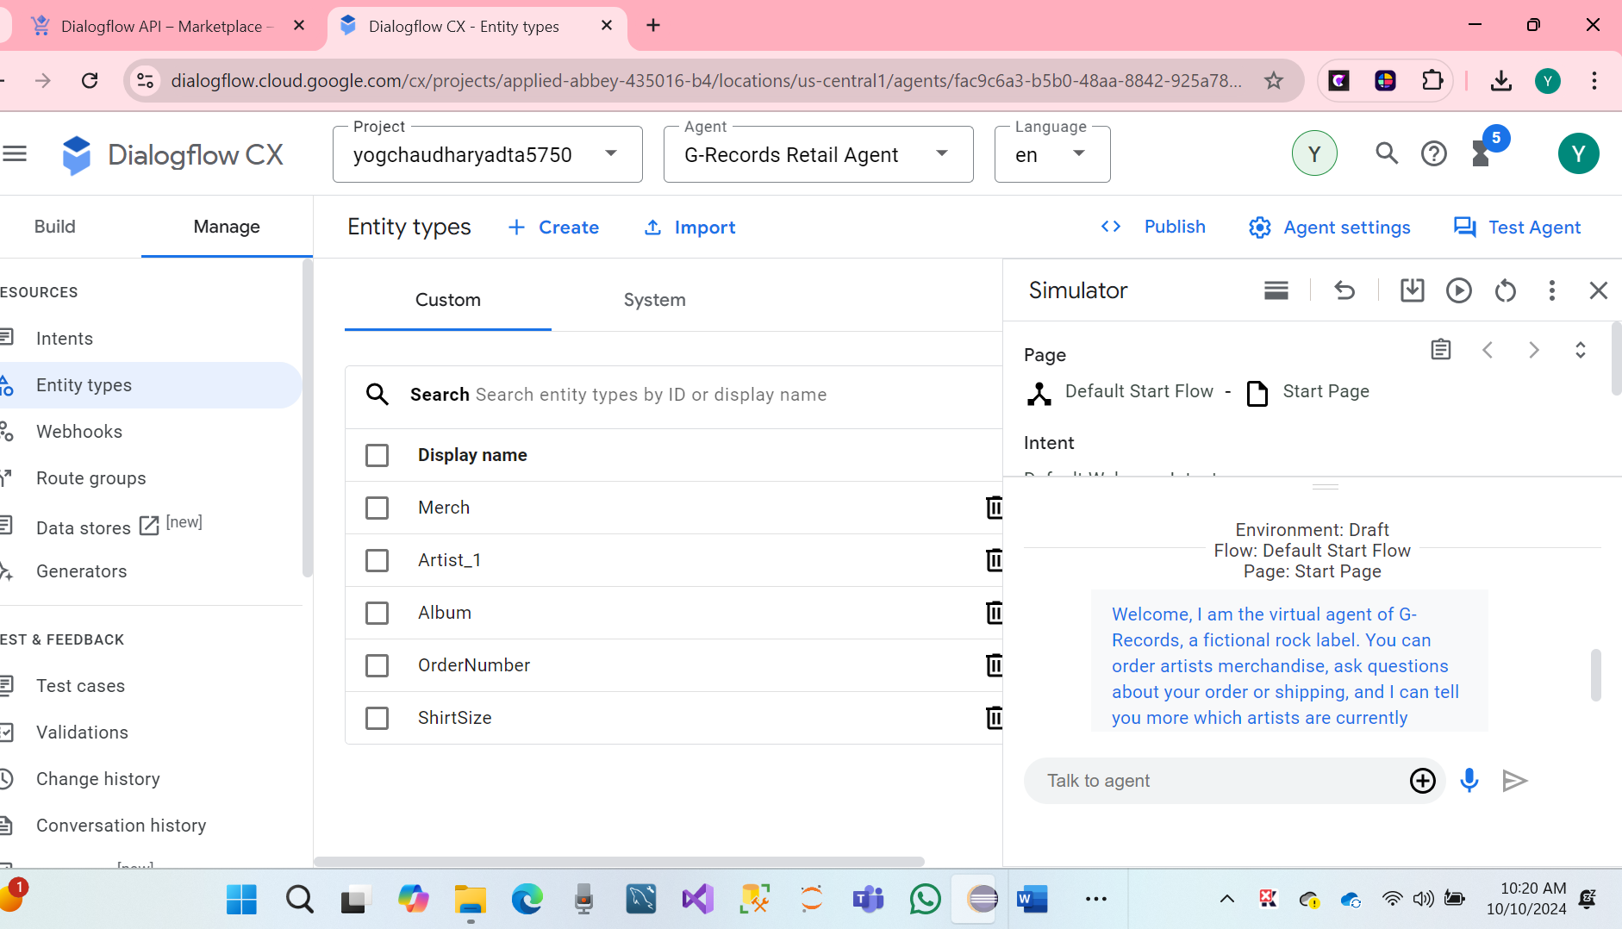

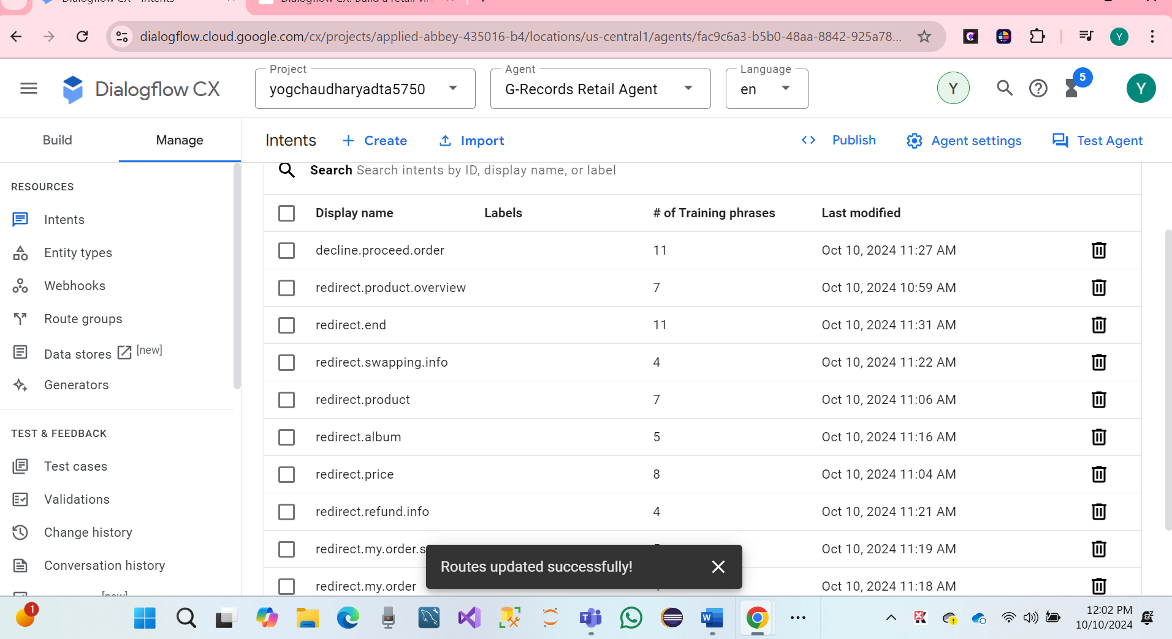

* We have Successfully 23-page Inten Routes.

**To- do #2 Following the steps discussed in the tutorial, complete the steps to set up pages and state handlers.**

We have a following step: Page & state Handers a Dialog flow CX as concepts.

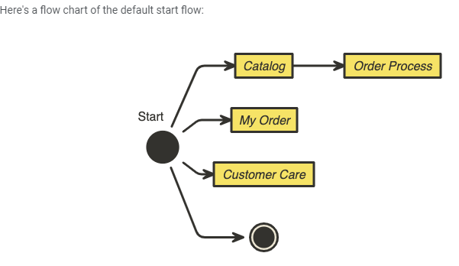

* Click Build > Default Start Flow
* Click the Start Page
* Click the + icon next to Routes
* Add redirect.artists.overview
* Scroll down to Transition, and transition to the Catalog flow.
* Hit Save
* Repeat the above steps for redirect.product.overview and the other 11 rows from this table:

|  |  |  |
| --- | --- | --- |
| **Page (In Flow)** | **Routes > Intent** | **Routes > Transition To** |
| Start | Default Welcome Intent | - |
| Start | redirect.artists.overview | Flow: Catalog |
| Start | redirect.product.overview | Flow: Catalog |
| Start | redirect.shirts | Flow: Catalog |
| Start | redirect.music | Flow: Catalog |
| Start | redirect.product | Flow: Catalog |
| Start | redirect.product.of.artist | Flow: Catalog |
| Start | redirect.refund.info | Flow: Customer Care |
| Start | redirect.shipping.info | Flow: Customer Care |
| Start | redirect.swapping.info | Flow: Customer Care |
| Start | redirect.my.order | Flow: My Order |
| Start | redirect.my.order.canceled | Flow: My Order |
| Start | redirect.my.order.status | Flow: My Order |
| Start | redirect.end | Page: End Session |

We have seen the Dialog flow CX with page intent Routs.

* Hare screenshot

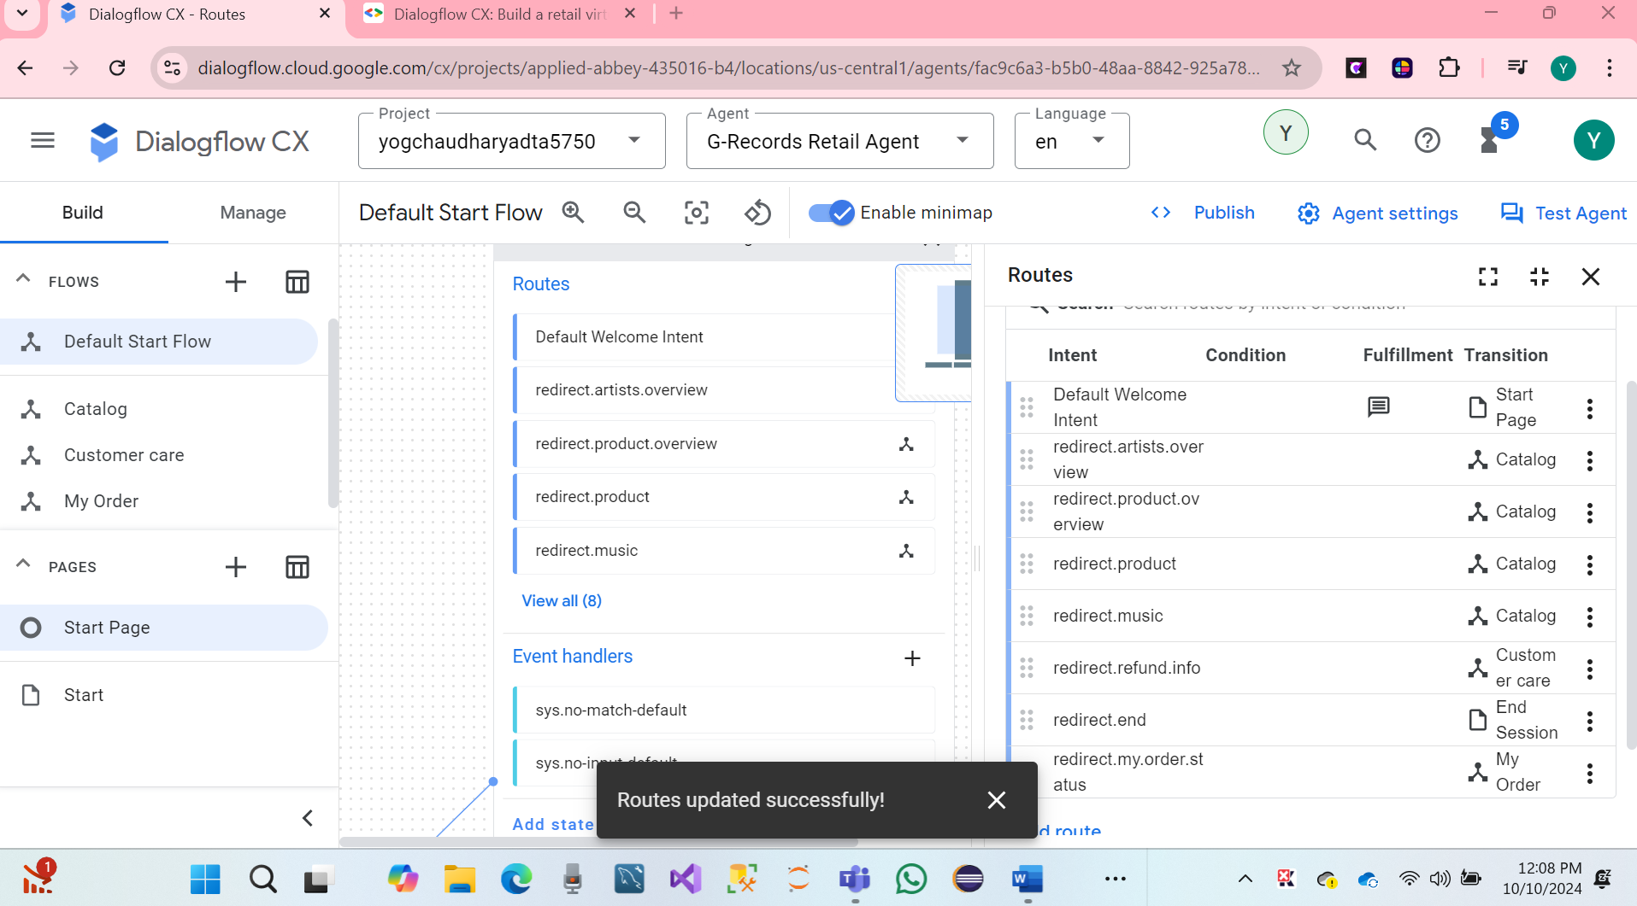

The **Default Start Flow** will function like an option menu in a call center, but with a more natural, conversation-driven interaction. In this virtual agent, the user interacts using **Natural Language Processing (NLP)**. Which are matched with the intents defined by training phrases, making the experience more human-like.

We have two important page Transition options: End Session and End Flow.

By default, Dialogflow CX follows the defined conversation flow until it reaches a conclusion. If, while navigating the conversation, the user is redirected to another flow, the agent will follow that new flow's pages until it finishes, and then return to the previously active flow. This process continues until the chat conversation explicitly ended using the **End Session** option.

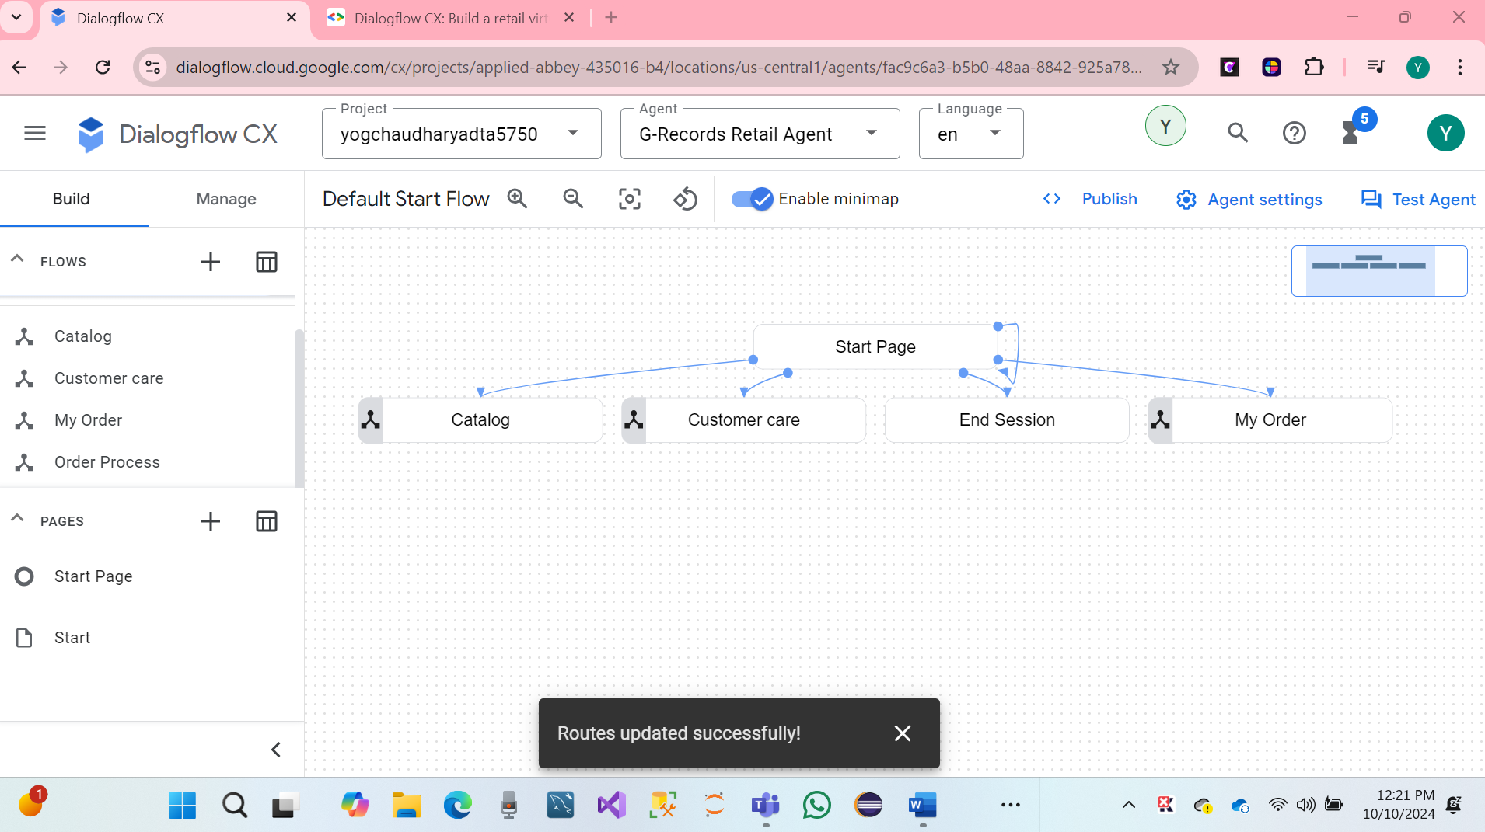

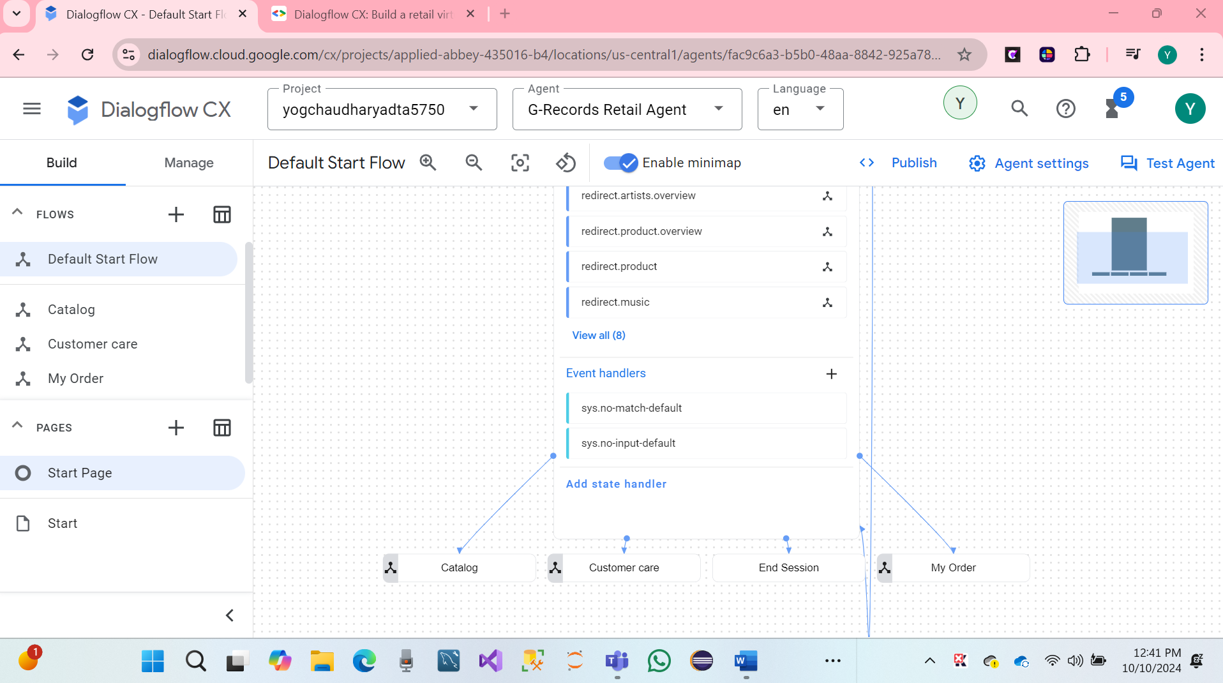

We have created a start with connection page.

* Click Build > **Catalog**
* Click the Start Page
* Click the + icon next to Routes
* Add redirect.artists.overview
* Scroll down to *Transition*, select Page and choose: + new Page
* Use the page name: Artist Overview and hit Save

The previous steps can be repeated with the following pages, intents and fulfillments. Take over this table. *Page*, is the Page you will select in the flow, *Routes > Transition To* is the new flow or page you will create and transition to

**List of Page, Routes Intents**

|  |  |  |
| --- | --- | --- |
| **Page (In Flow)** | **Routes > Intent** | **Routes > Transition To** |
| Catalog Start | redirect.artists.overview | Artist Overview |
| **Catalog Start** | redirect.product | Product |
| Catalog Start | redirect.product.overview | Product Overview |
| Catalog Start | redirect.product.of.artist | Product Overview |
| Catalog Start | redirect.shirts | Shirts |
| Catalog Start | redirect.music | Music |
| Catalog Start | redirect.end | End Session |
| Catalog Start | redirect.home | End Flow |
| Catalog Start | redirect.product.of.artist | Product Overview |

* Hare Screenshot created Intents**.**

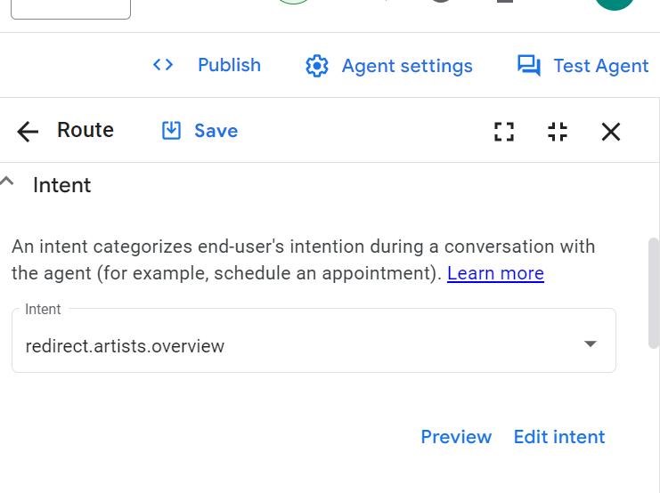 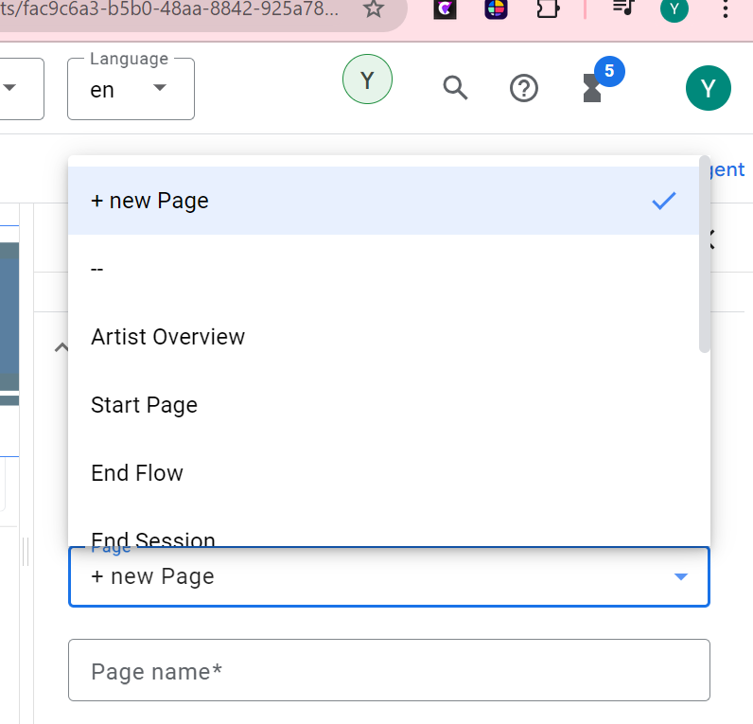

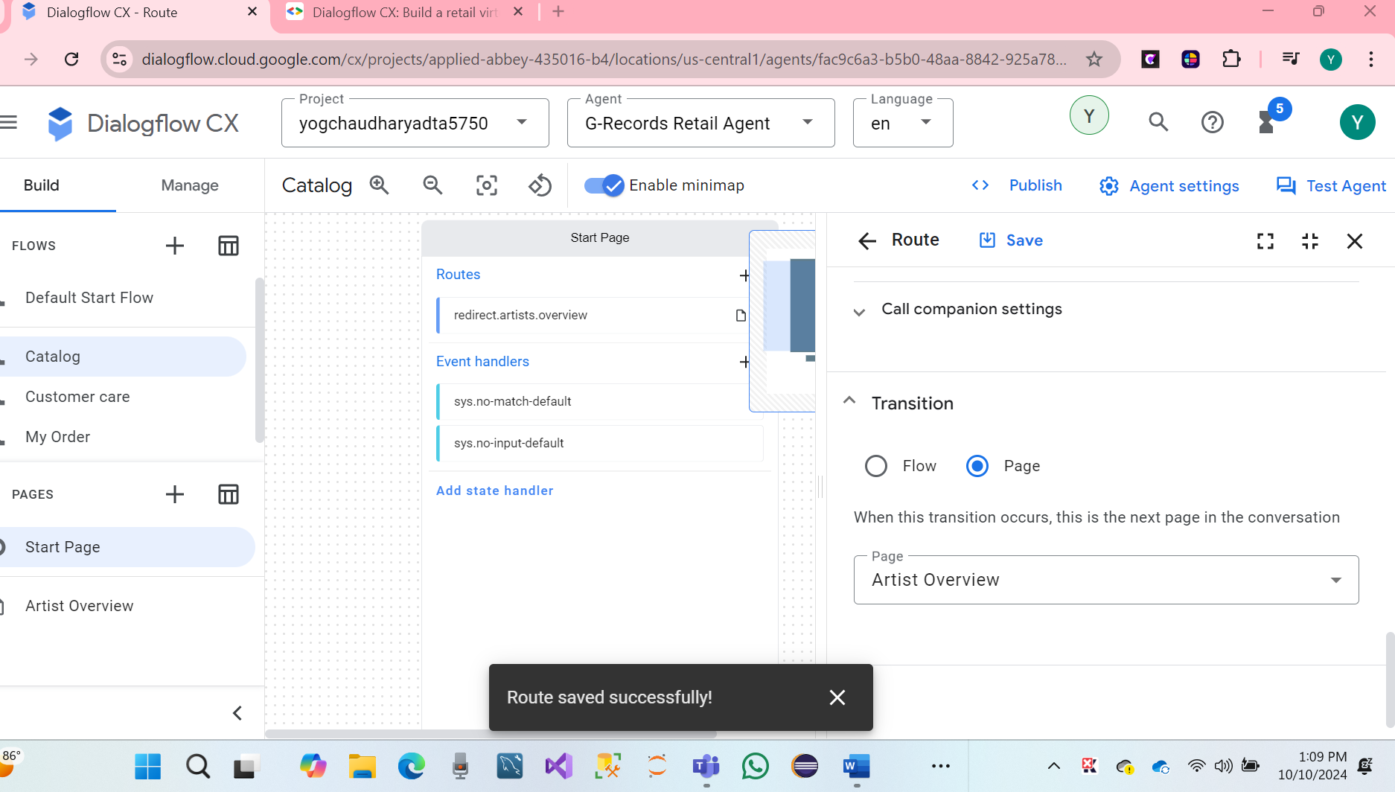

We can see Created Page Artist Overview.

* Hare Screenshot

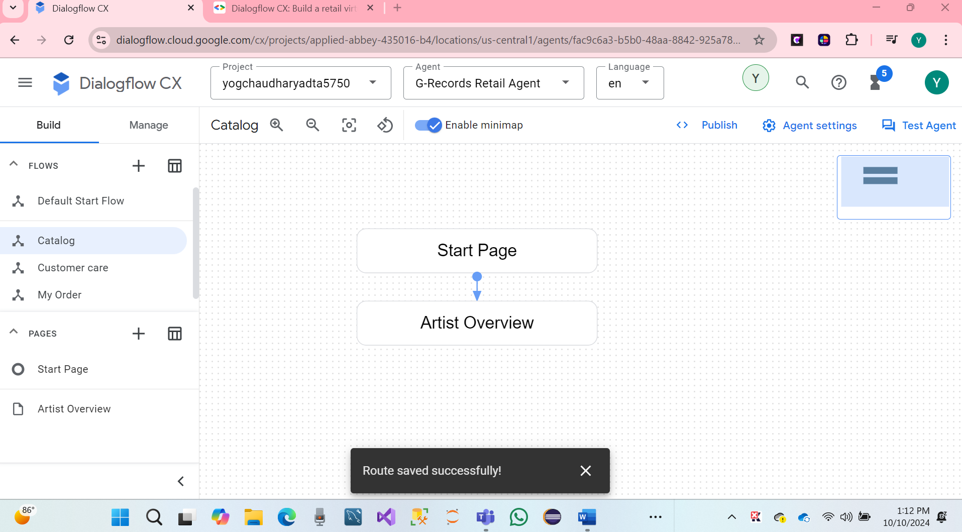

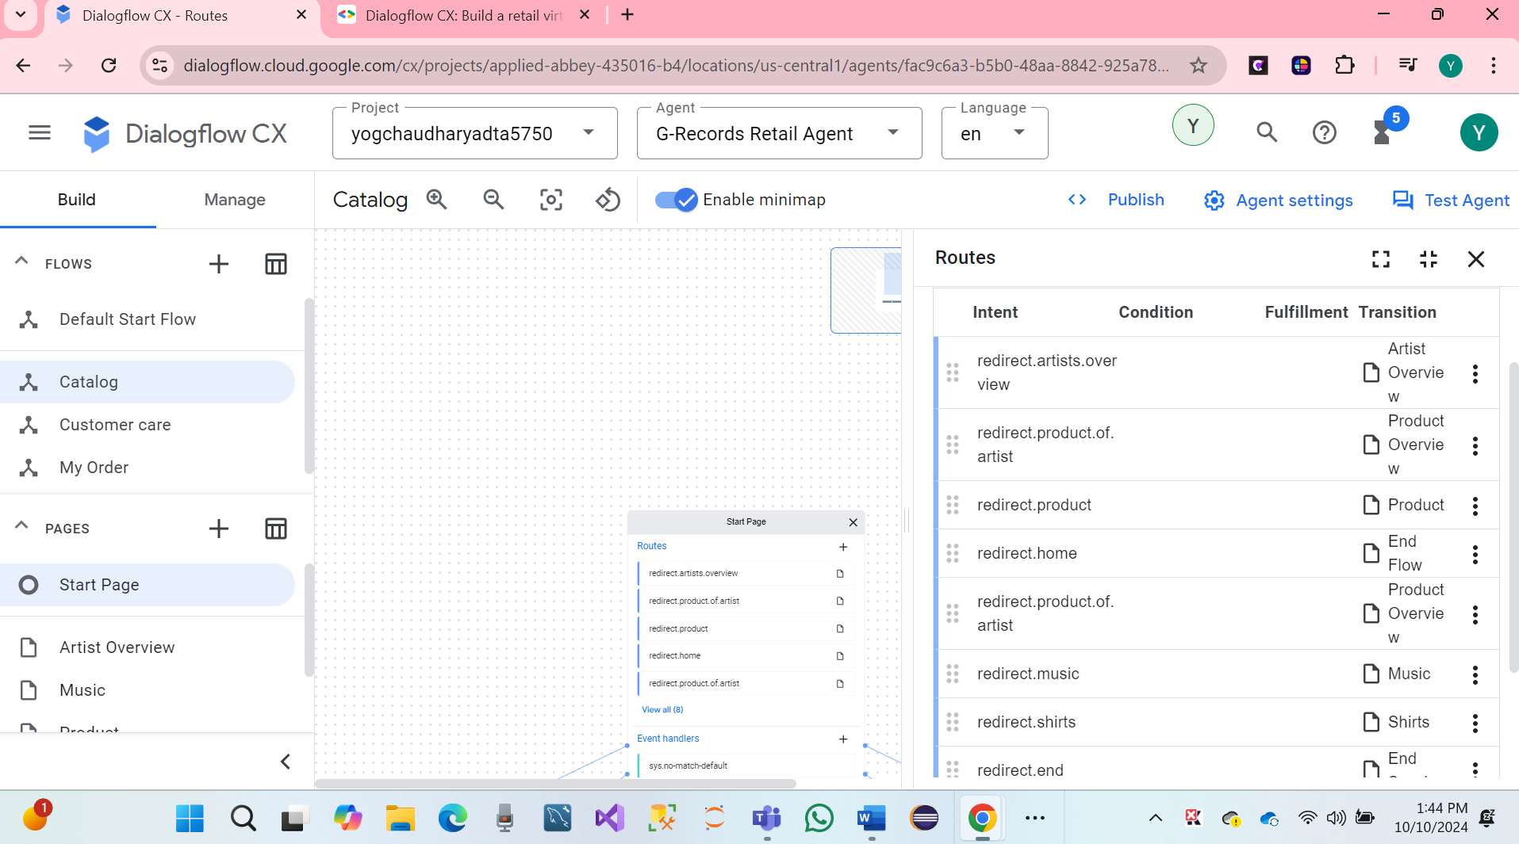

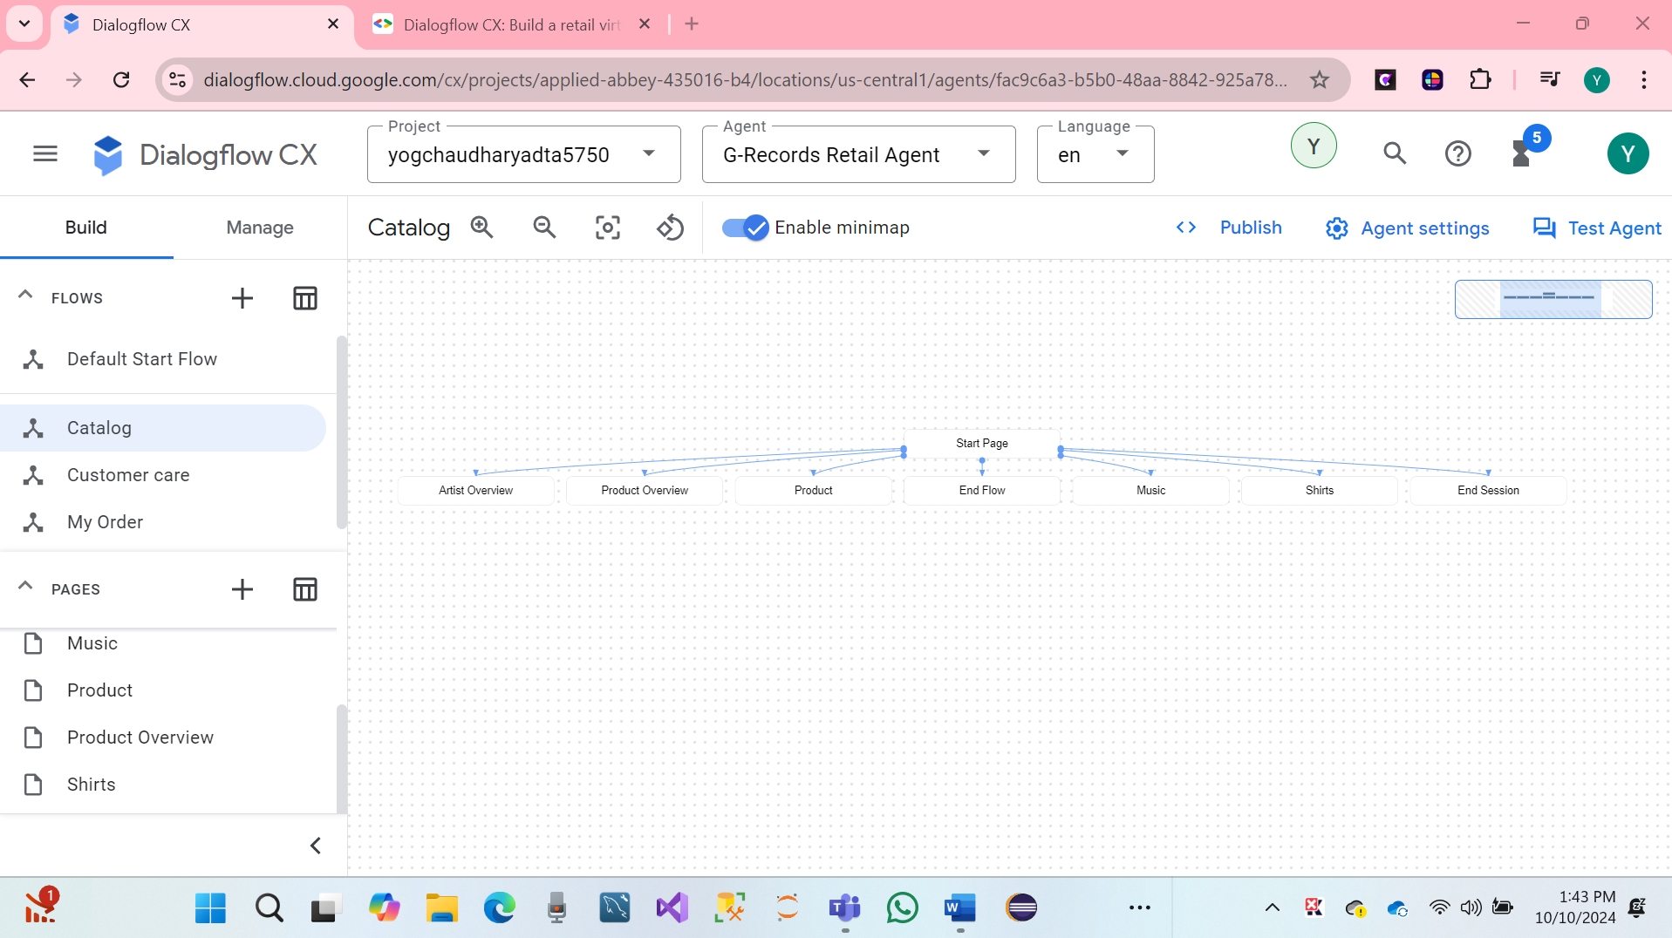

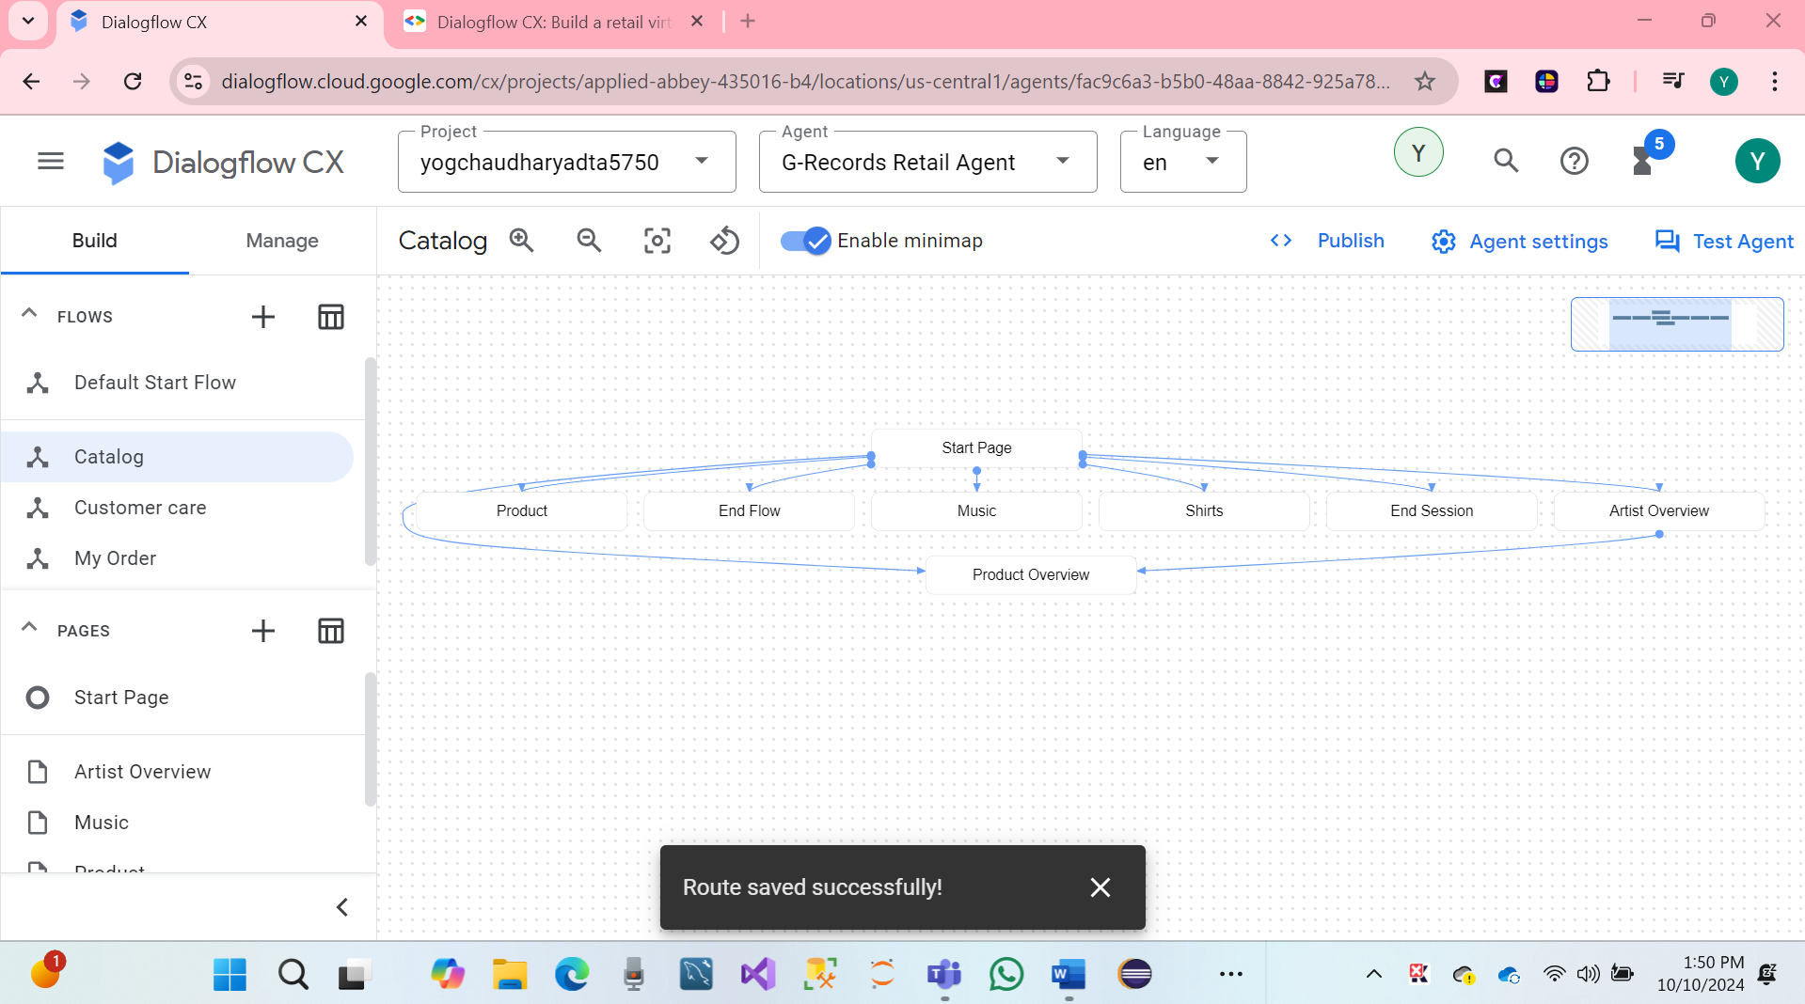

* In the Catalog flow, click on the Artist Overview page.
* Click Edit fulfillment in the Entry fulfillment section.
* Use the following static fulfillments (Agent says):

**The following bands are signed with G-Records: Alice Googler, G's N' Roses, The Goo Fighters and The Google Dolls**.

* Click Save
* In the Catalog flow, click on the Product Overview page.
* Click Edit fulfillment in the Entry fulfillment section.
* Use the following static fulfillment (Agent says):
* **We sell shirts, music or the tour movie.**
* Hit Save.

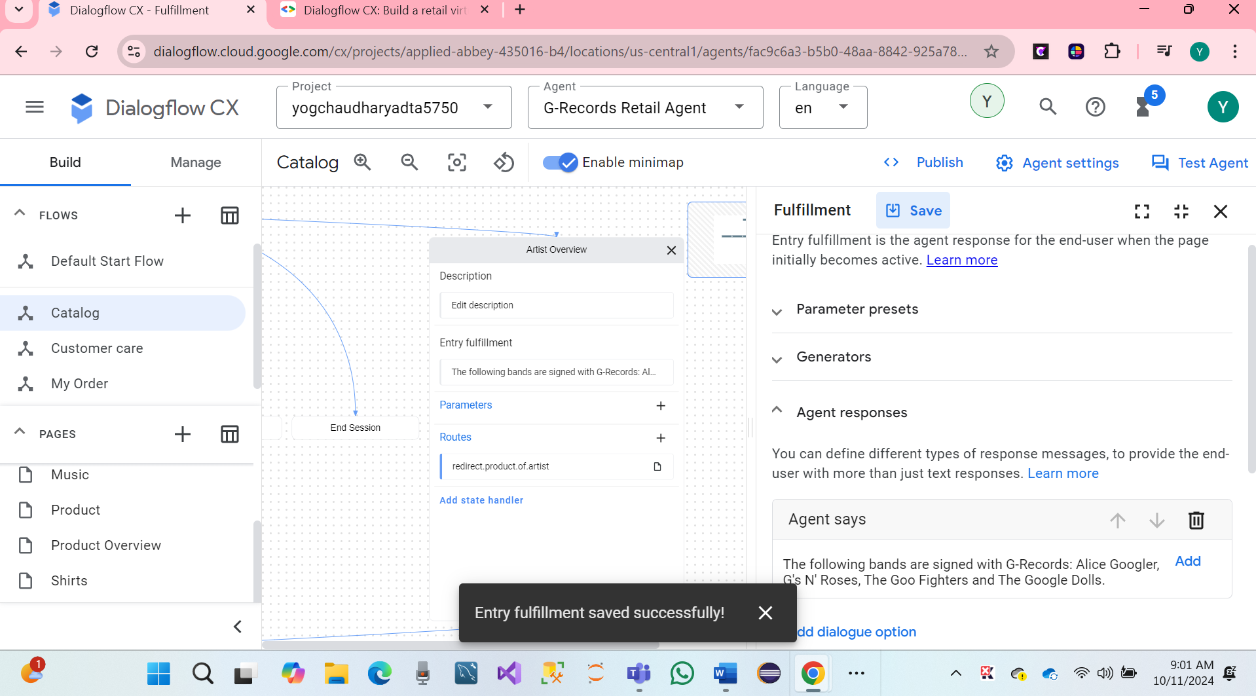

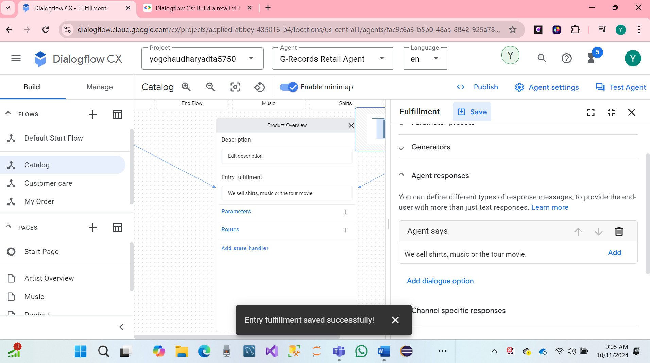

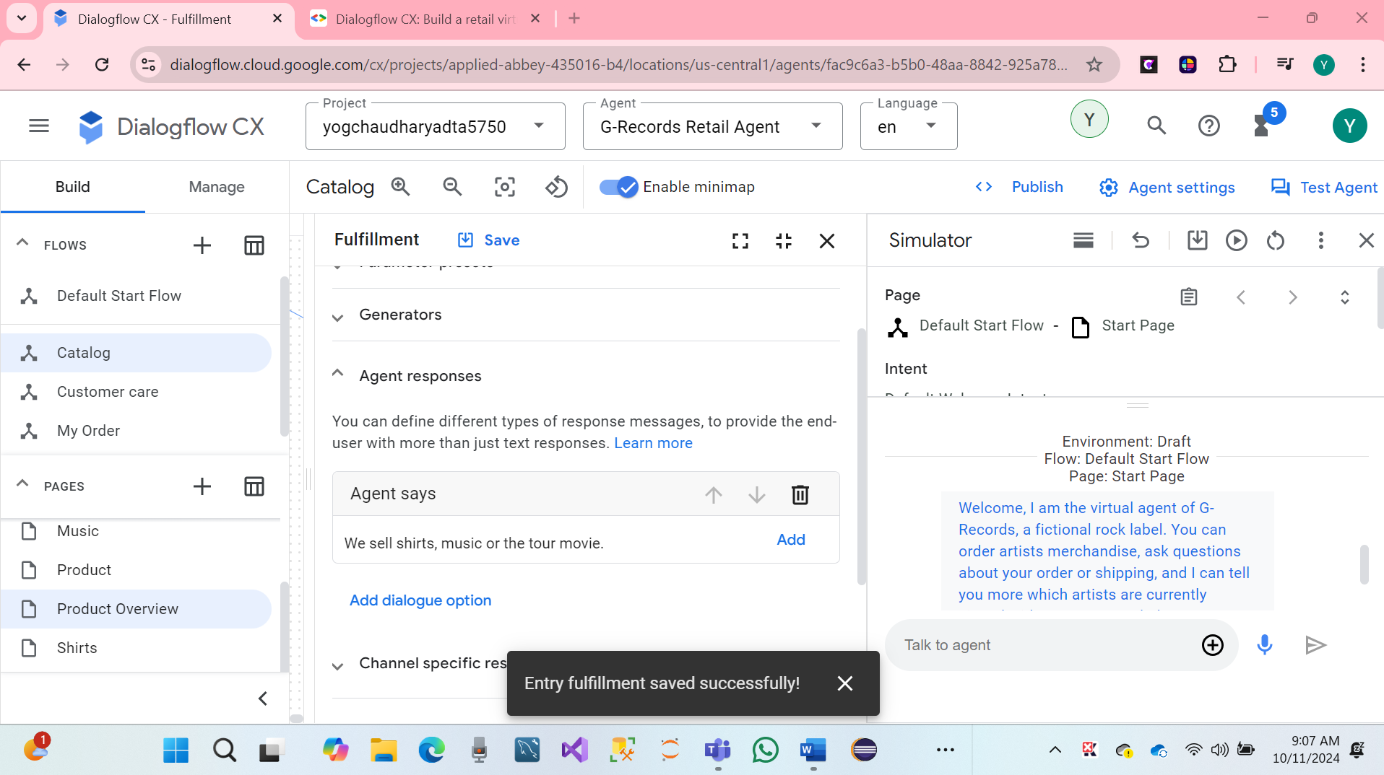

* **Page Parameters**

Parameters in Dialogflow CX capture and reference user-provided values during a session. For a merchandise order, required parameters include @Artist, @Merch, and, depending on the item, @ShirtSize, @Carrier, and @Album. Marking parameters as required ensures the agent collects them, with custom prompts reminding users to provide necessary details. Dialogflow CX allows custom static fulfillment messages for required parameters, which are added to the response queue. Multiple fulfillments can be triggered in one turn, with responses managed in the queue. For more details on the page lifecycle and response order, refer to the Dialogflow CX documentation on pages.

We have In the Catalog Flow, click on the Artist Overview page.

* Click the + in the Parameters block. Add the artist parameter:
* Display Name: artist
* Entity Type: @Artist
* Required: Check
* Redact in log: Check

Now we will add some custom parameter fulfillment messages. If the *artist* parameter haven't been collected by the virtual agent yet, the end user will get this agent response added to the response queue:

* From which of these artists would you like to order merchandise?

Add a second dialogue option that provides rich suggestion chips. Click **Add dialogue option** and use this code (in [JSON](https://en.wikipedia.org/wiki/JSON)):

{  
  "richContent": [  
    [  
      {  
        "options": [  
          {  
            "text": "The Google Dolls"  
          },  
          {  
            "text": "The Goo Fighters"  
          },  
          {  
            "text": "Alice Googler"  
          },  
          {  
            "text": "G's N' Roses"  
          }  
        ],  
        "type": "chips"  
      }  
    ]  
  ]  
}

**We can see successfully parameters.**

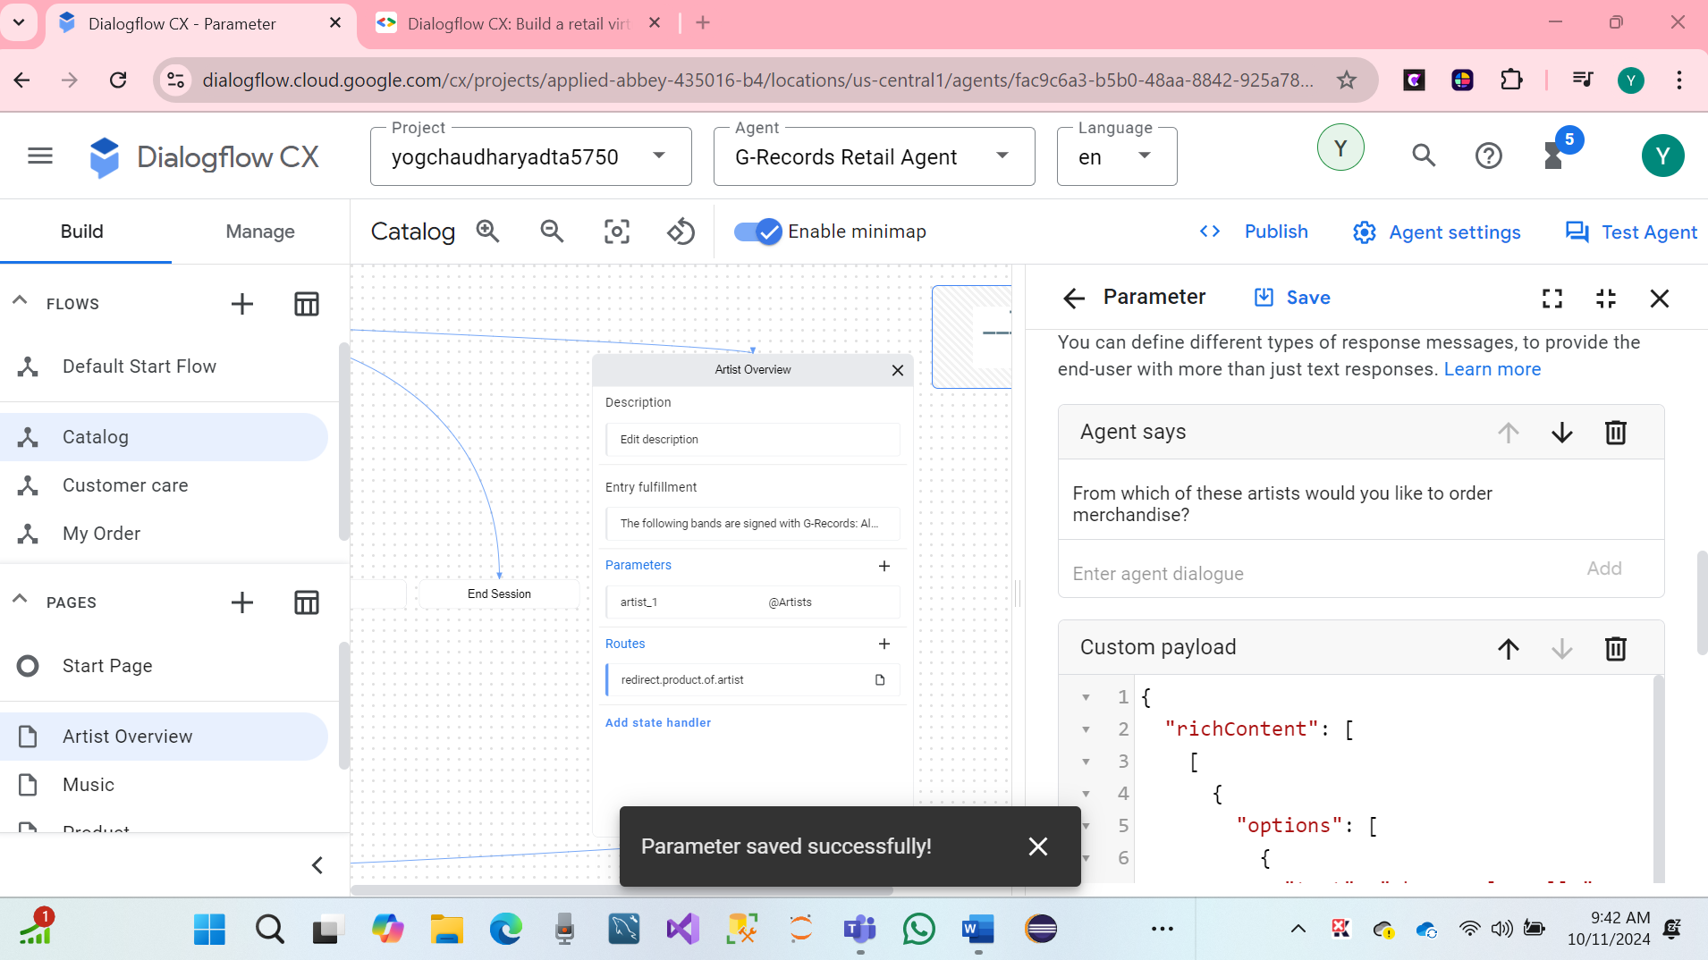

We have Scroll down to the Reprompt event handlers section.

* Click Add event handler and select the event: No-match default
* Use the following event static text fulfillment

I missed that. Please, specify the artist. You can choose between: Alice Googler, G's N' Roses, The Google Dolls or The Goo Fighters. Which artist do you want to buy merchandise from?

* Click Save
* Click Add event handler ans select the event: No-input default
* Use the following event static text fulfillment:
* Hare Screenshot.

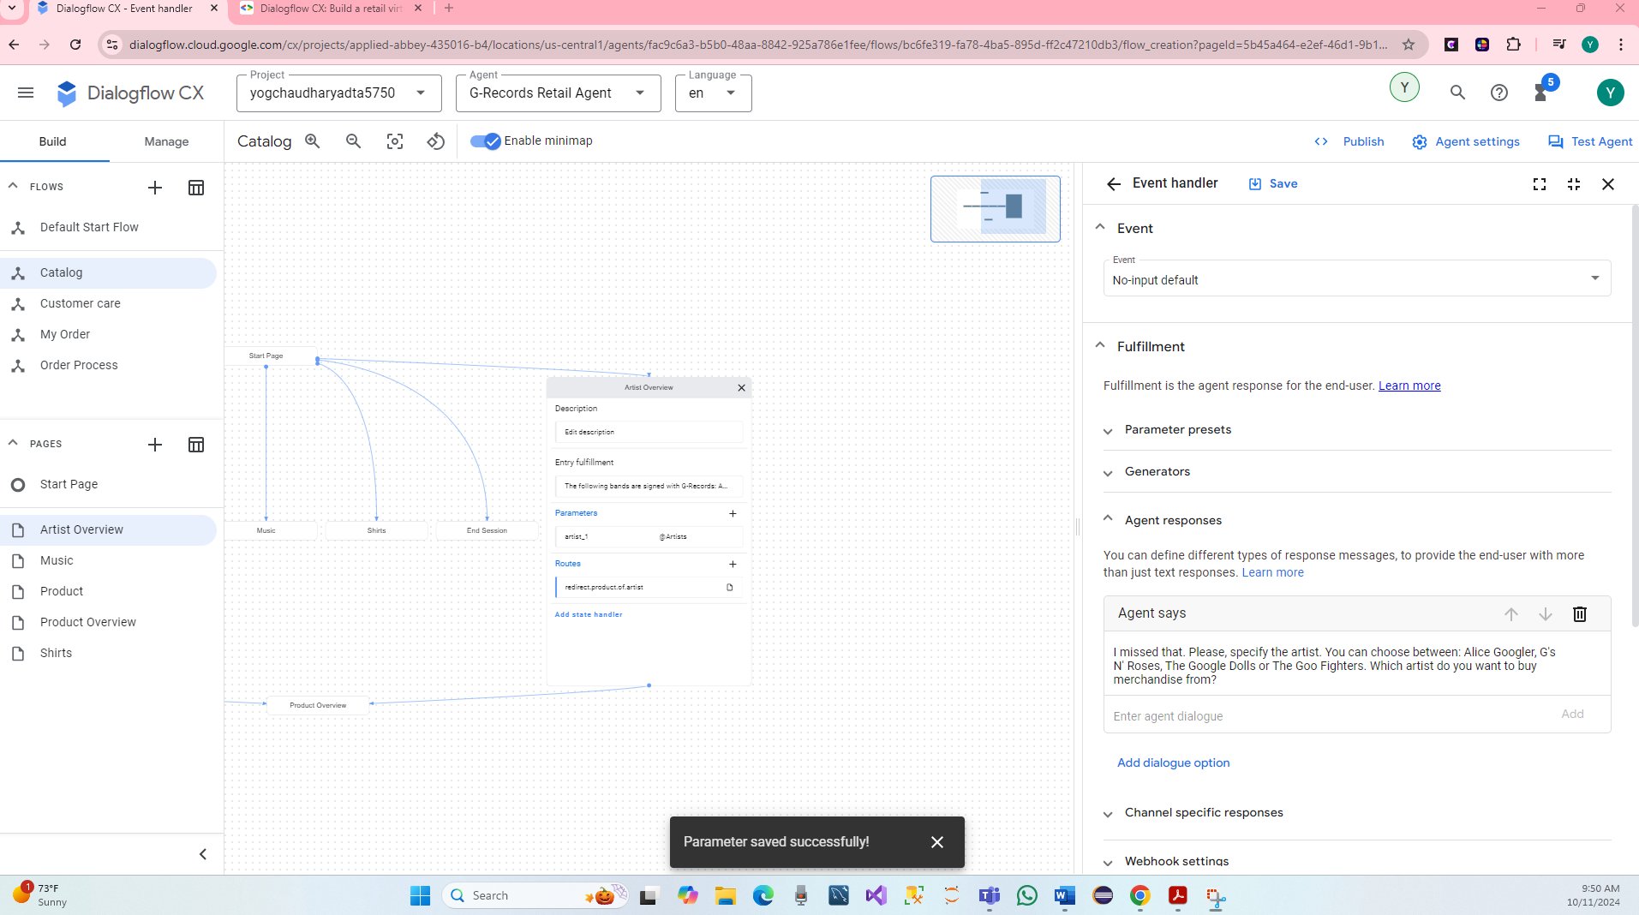

I am sorry, I could understand the artist's name. We can choose between Alice Googler, G's N' Roses, The Google Dolls or The Goo Fighters. Which artist do you want to buy merchandise from?

* Click on Save.

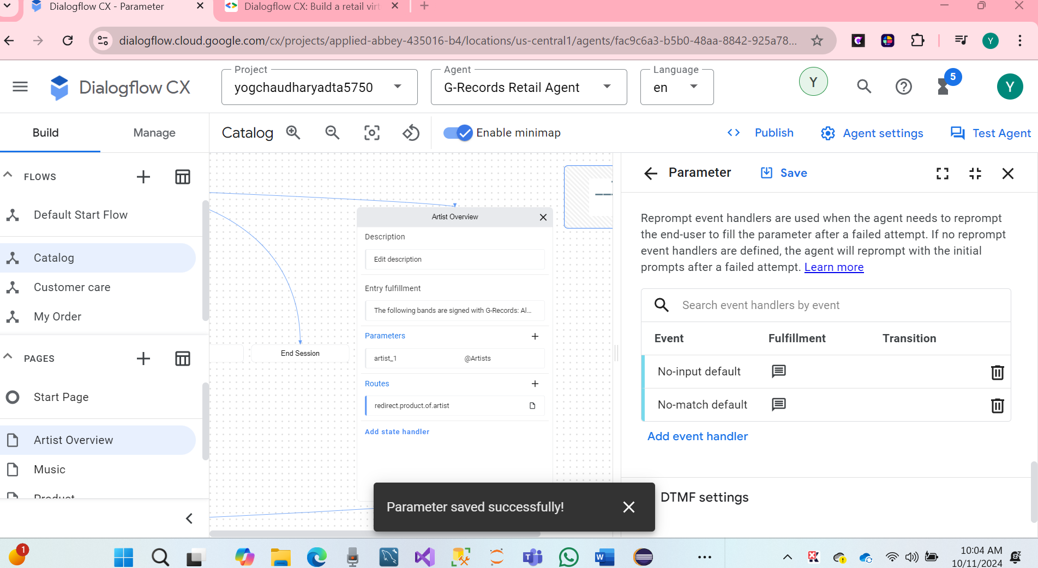

**We can see hare in the Dialogflow CX on the created build for flows: Catalog.**

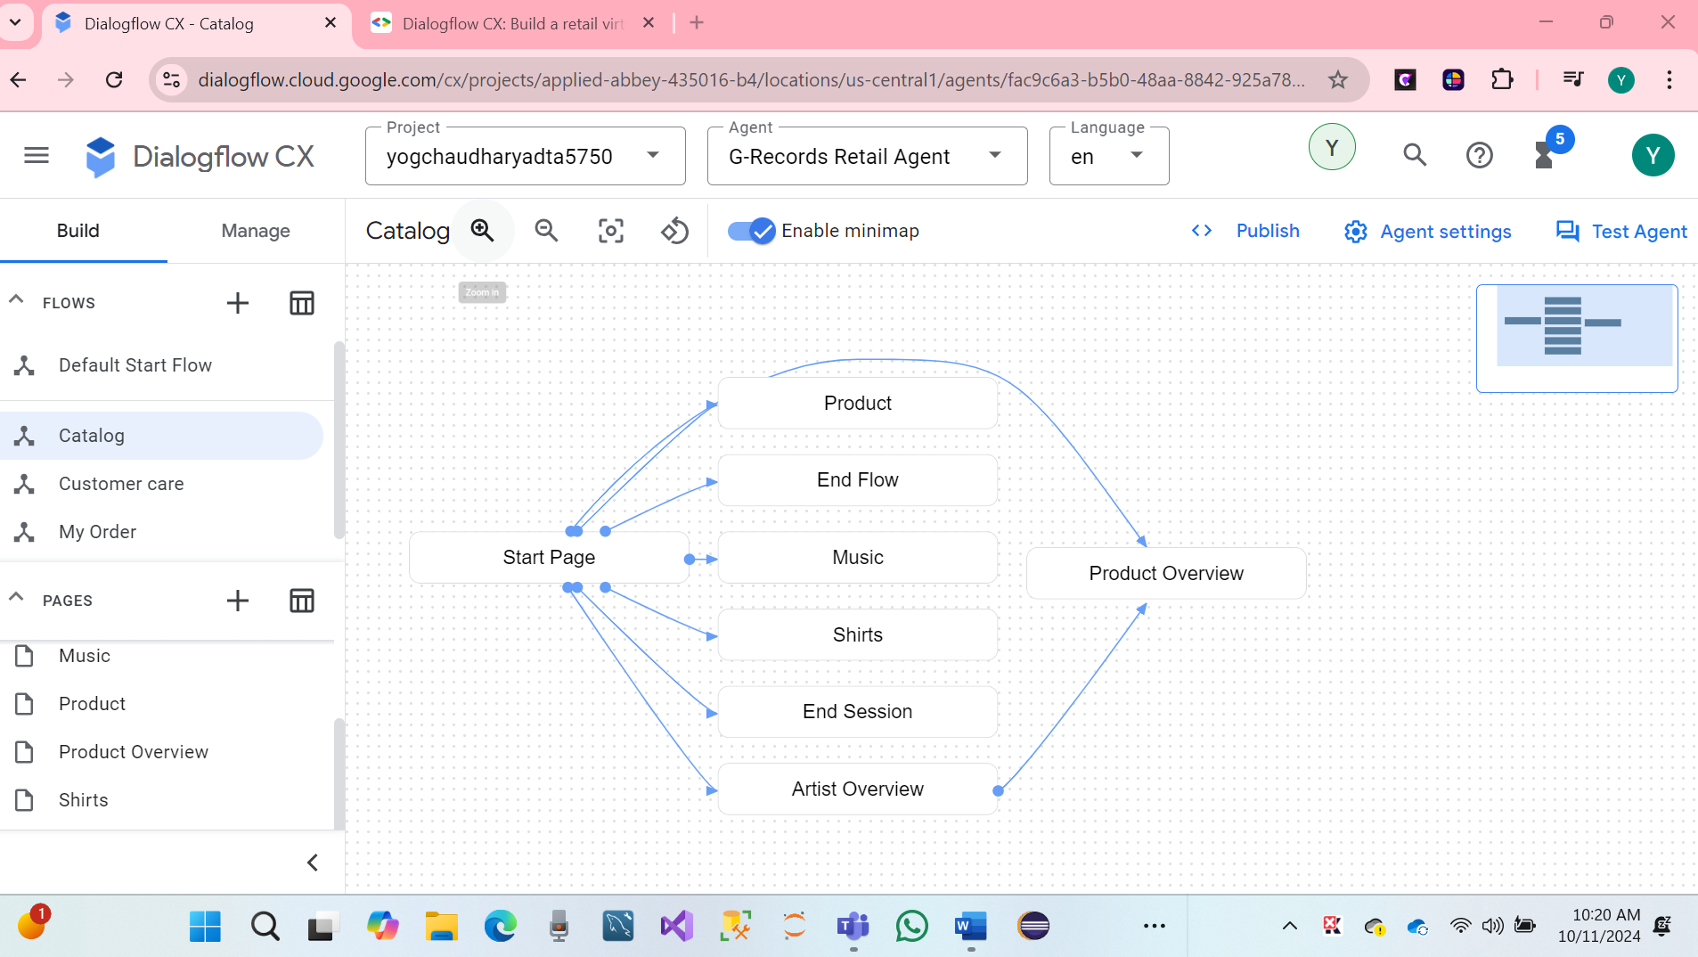

**After that Test Agent.**

* Hare Screenshot.

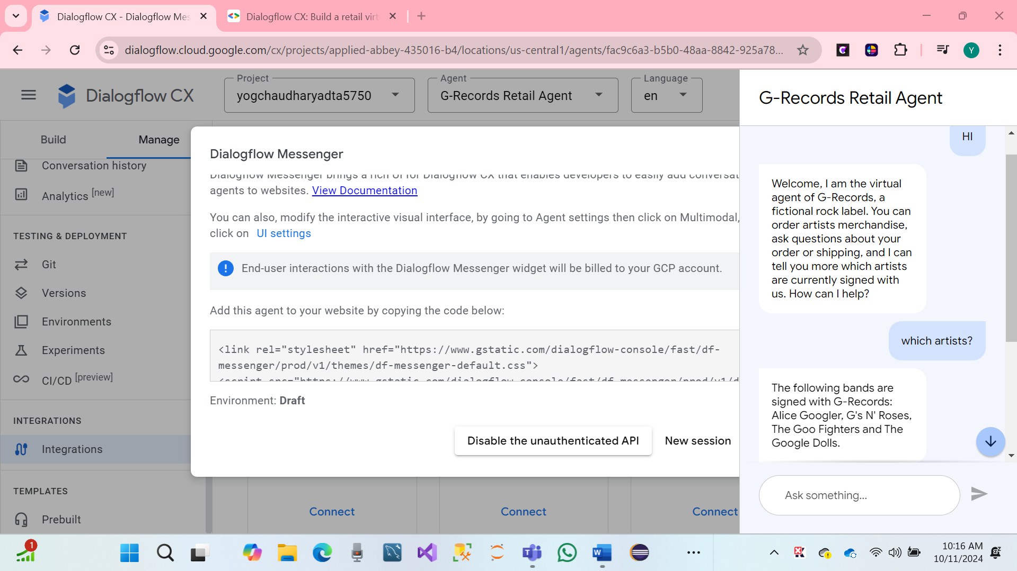

* **Page Condition Routes**

In Dialogflow CX, parameters combined with Page Conditional Routes allow powerful interactions. A condition triggers a route when it evaluates to true, such as when a parameter equals a specific value, or a form is completed. For a retail virtual agent, parameters are collected in a sequence, forming a "form" that the agent completes through multiple turns. The virtual agent interacts with users until all required parameters are gathered. To check if the form on the current page is complete, use the condition $page.params.status = "FINAL". More details on parameters and conditions can be found in the Dialogflow CX documentation.

**We have Creating the conditional routes on the Artist Overview page, which will transition to the next page**

* In the Artist Overview page, click on the + icon in the Routes section.
* Scroll down to the Condition section.
* Select At least one (OR)
* Next, we will write an expression that
* Parameter: $page.params.status
* Operator: =
* Value: "FINAL"

Now, we will create a specific static fulfillment message on the route, confirming the end user's choice. Scroll down to the Fulfillment block and write the following fulfillment messages:

* $session.params.artist, great choice! Rock on!
* We want to rock with $session.params.artist merchandise. Awesome!

After the condition is true, you should transition to the Product Overview page. Scroll down to the Transition section and use the following page: Product Overview.

* Hit click on save.
* Hare screenshot.

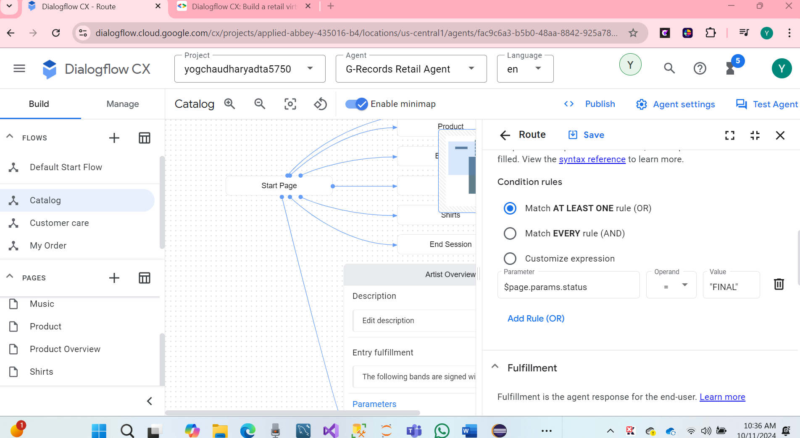

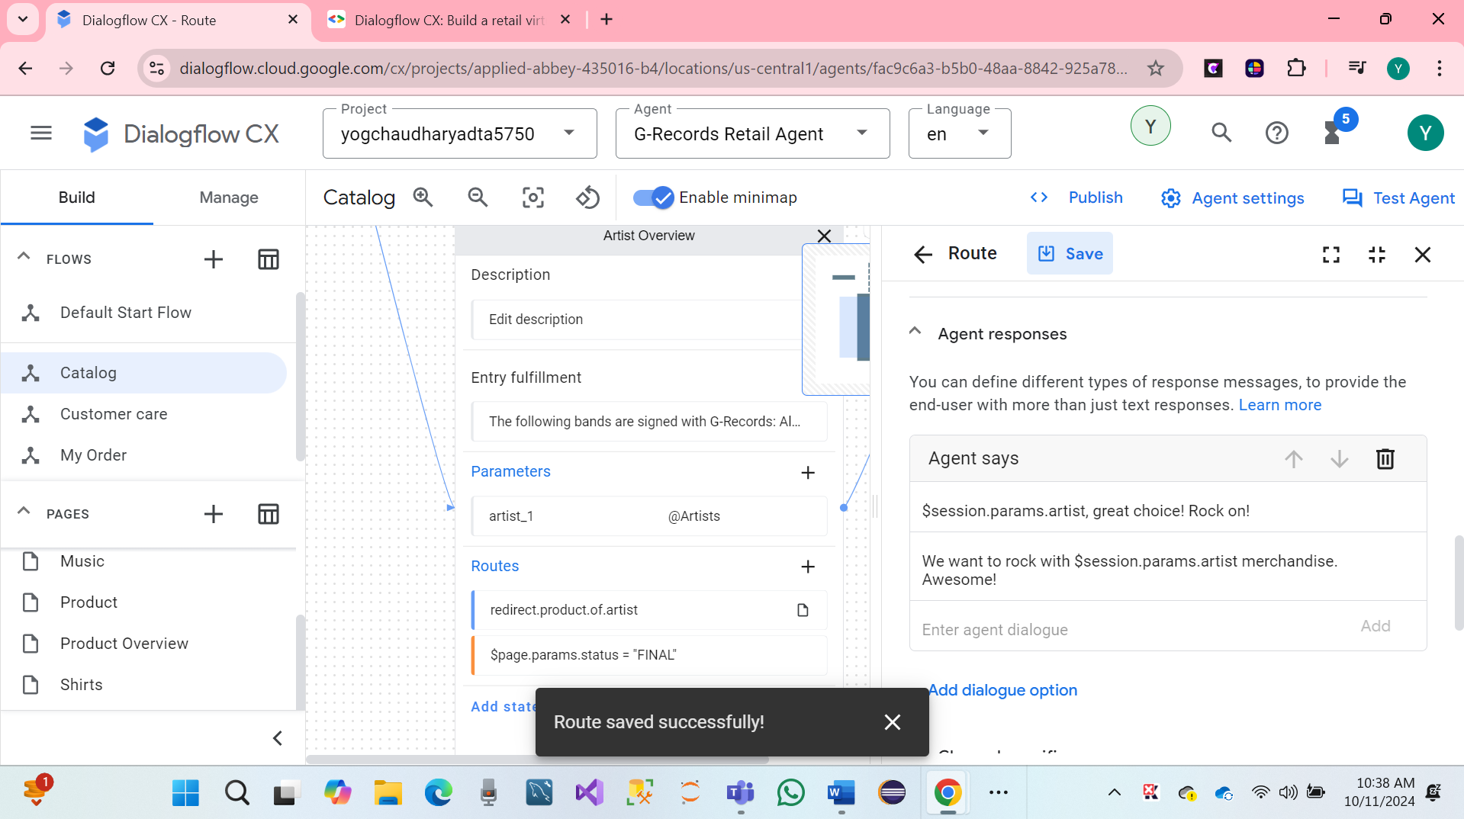

We have again created the routes on the Product Overview page. which should create parameters and conditional routes, following steps.

Click on the product Overview page on Create artist parameter.

* Display Name: artist
* Entity Type: @Artist
* Required: Check
* Redact in log: Check
* Initial prompt fulfillment: From which of these artists would you like to order merchandise?

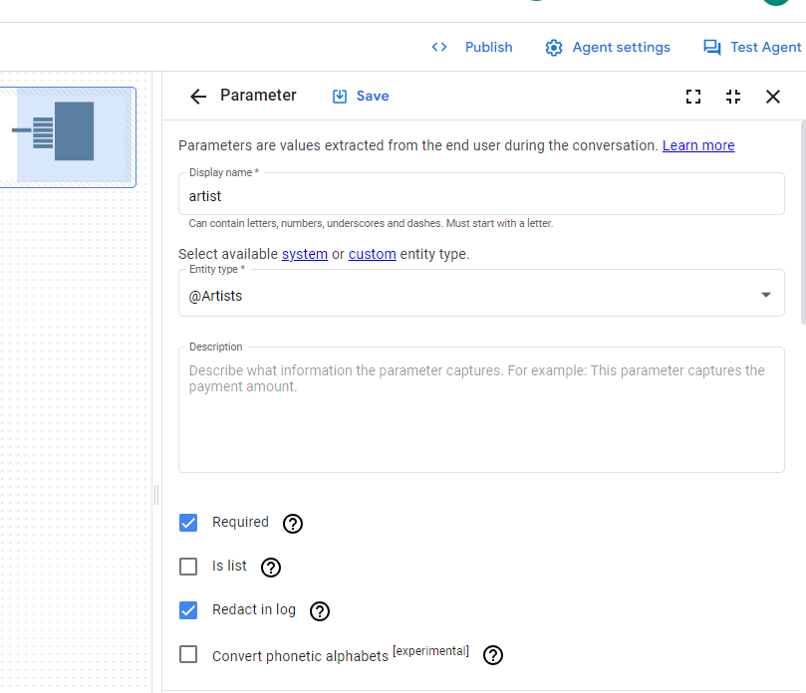 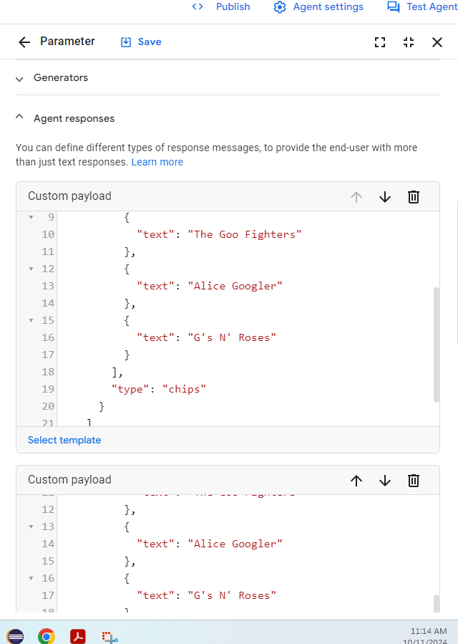

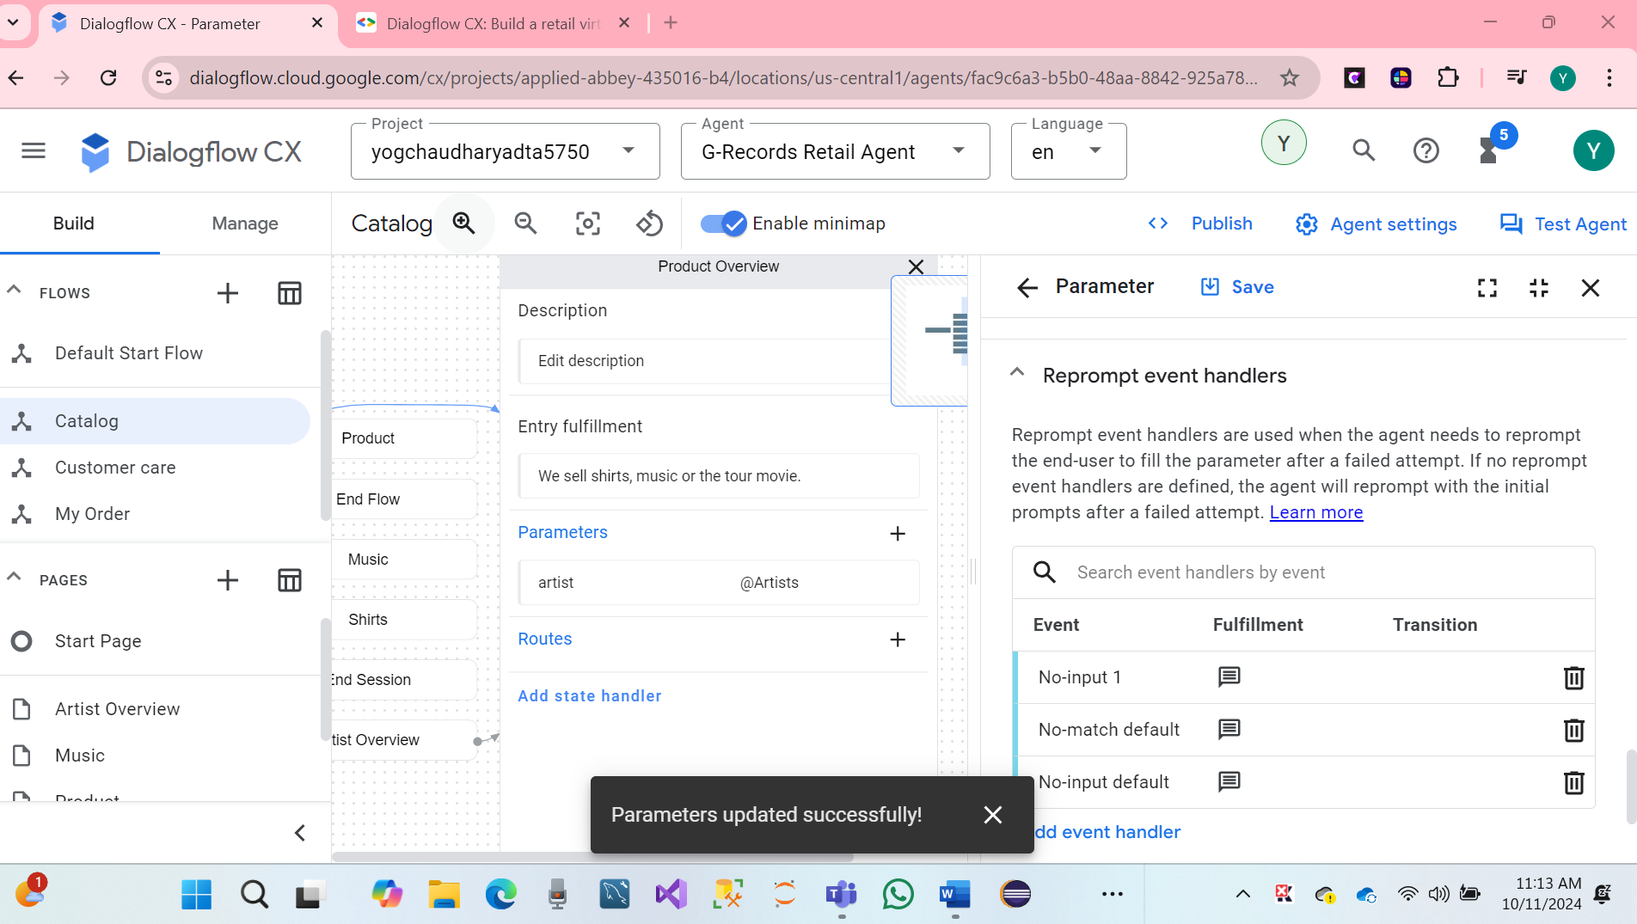

We have Create a route which will transition to the Product page for when artist is provided, and the merch item is provided.

**Condition:**

* Match Every rule (AND)
* Expression: $session.params.artist != null
* Expression: $session.params.merch != null
* Fulfillment: Alright! $session.params.merch of $session.params.artist, let's go!
* Transition: Page: Product

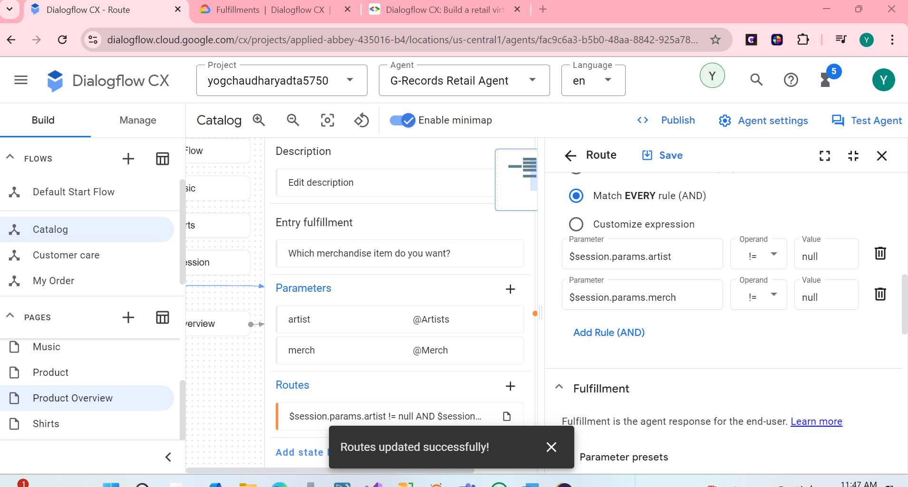

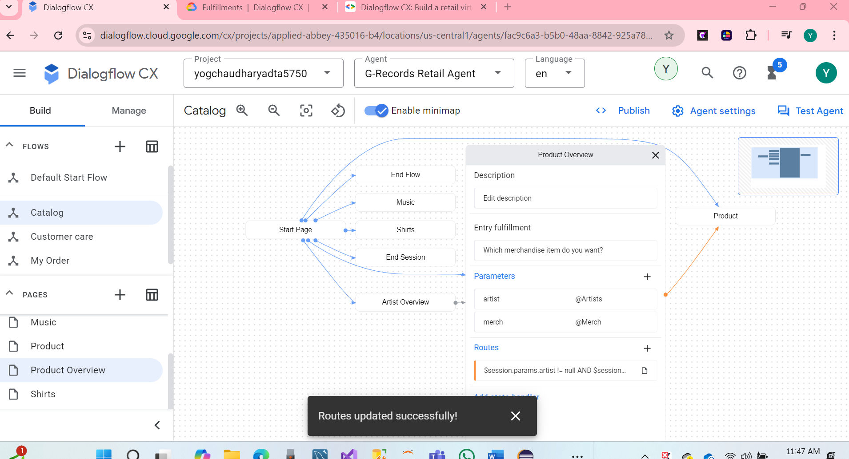

* We can see hare screenshot

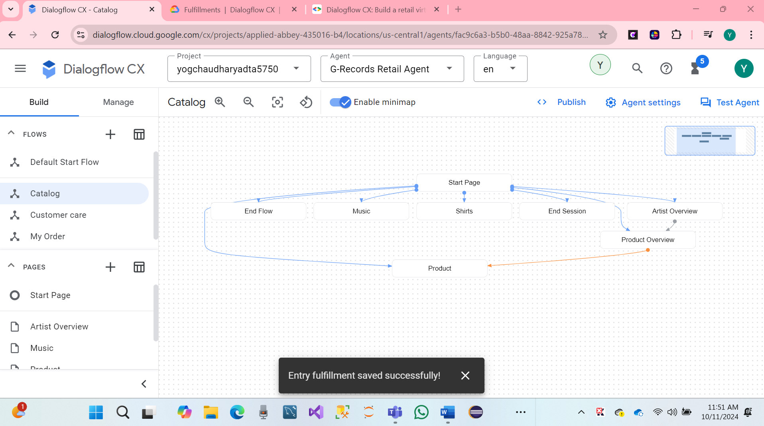

We have Create a route for when the user says "Shirts"

* Intent: redirect.shirts
* Transition: Page: Shirts

Create a route for when the user says "Music"

* Intent: redirect.music
* Transition: Page: Music

Create a route for when the user ask for price information

* Intent: redirect.price
* Transition: Create new Page: Price

**We can see hare Screenshot.**

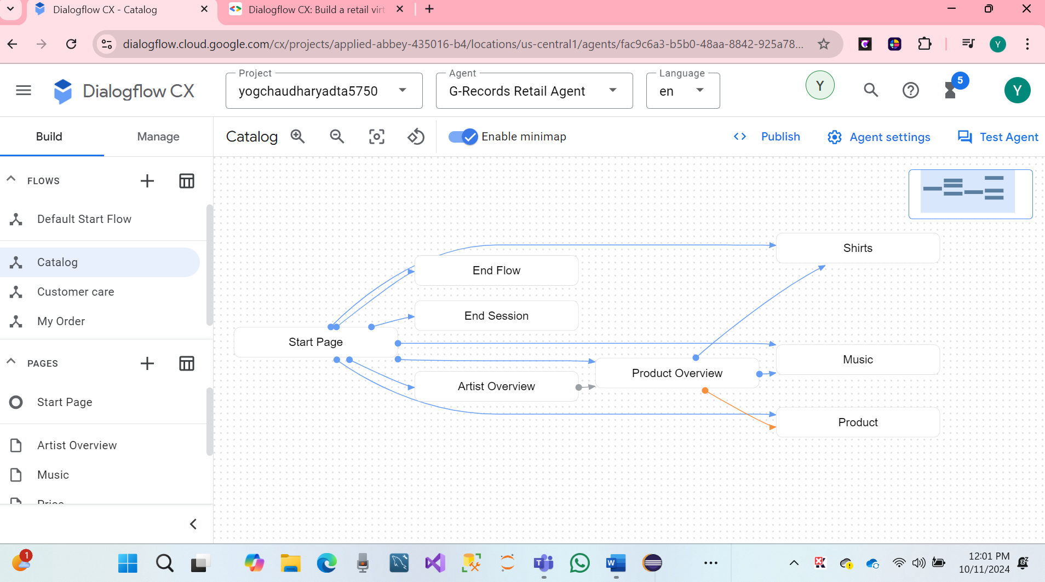

Now we have created Flows, Entities, Intents, and Pages with State Handlers like: Intent Routes and Conditional Routes based on Parameters.

We can see the following configuration on the created Shirts page of our virtual agents.

* Entry fulfillment: Do you want a longsleeve or a t-shirt?
* Entry fulfillment Custom payload:
* {  
      "richContent": [  
        [  
          {  
            "type": "chips",  
            "options": [  
              {  
                "text": "T-shirt"  
              },  
              {  
                "text": "Longsleeve"  
              },  
              {  
                "text": "Price?"  
              }  
            ]  
          }  
        ]  
      ]  
    }

Create an **Intent Route**: redirect.price with a transition to the Price Page

Create the following parameter:

* Parameter: merch - Entity Type: @Merch, Required and Redact in log
* Parameter > Event Handler > No-match default
* Parameter > Event Handler Fulfillment: You can choose between a t-shirt or a longsleeve. Which of these do you want?
* Parameter > Event Handler Fulfillment Custom payload:
* {  
      "richContent": [  
        [  
          {  
            "type": "chips",  
            "options": [  
              {  
                "text": "T-shirt"  
              },  
              {  
                "text": "Longsleeve"  
              }  
            ]  
          }  
        ]  
      ]  
    }

Parameter > Event Handler > No-input default

Parameter > Event Handler Fulfillment: I couldn't understand if you want the t-shirt or the longsleeve. Which of these do you want?

Parameter > Event Handler Fulfillment Custom payload:

{  
    "richContent": [  
      [  
        {  
          "type": "chips",  
          "options": [  
            {  
              "text": "T-shirt"  
            },  
            {  
              "text": "Longsleeve"  
            }  
          ]  
        }  
      ]  
    ]  
  }

Click on the entry fulfillment and scroll down to **Parameter presets**, each time when the Shirts page gets active, the category parameter will be set to *shirts*:

* Parameter: Category
* Value: shirts

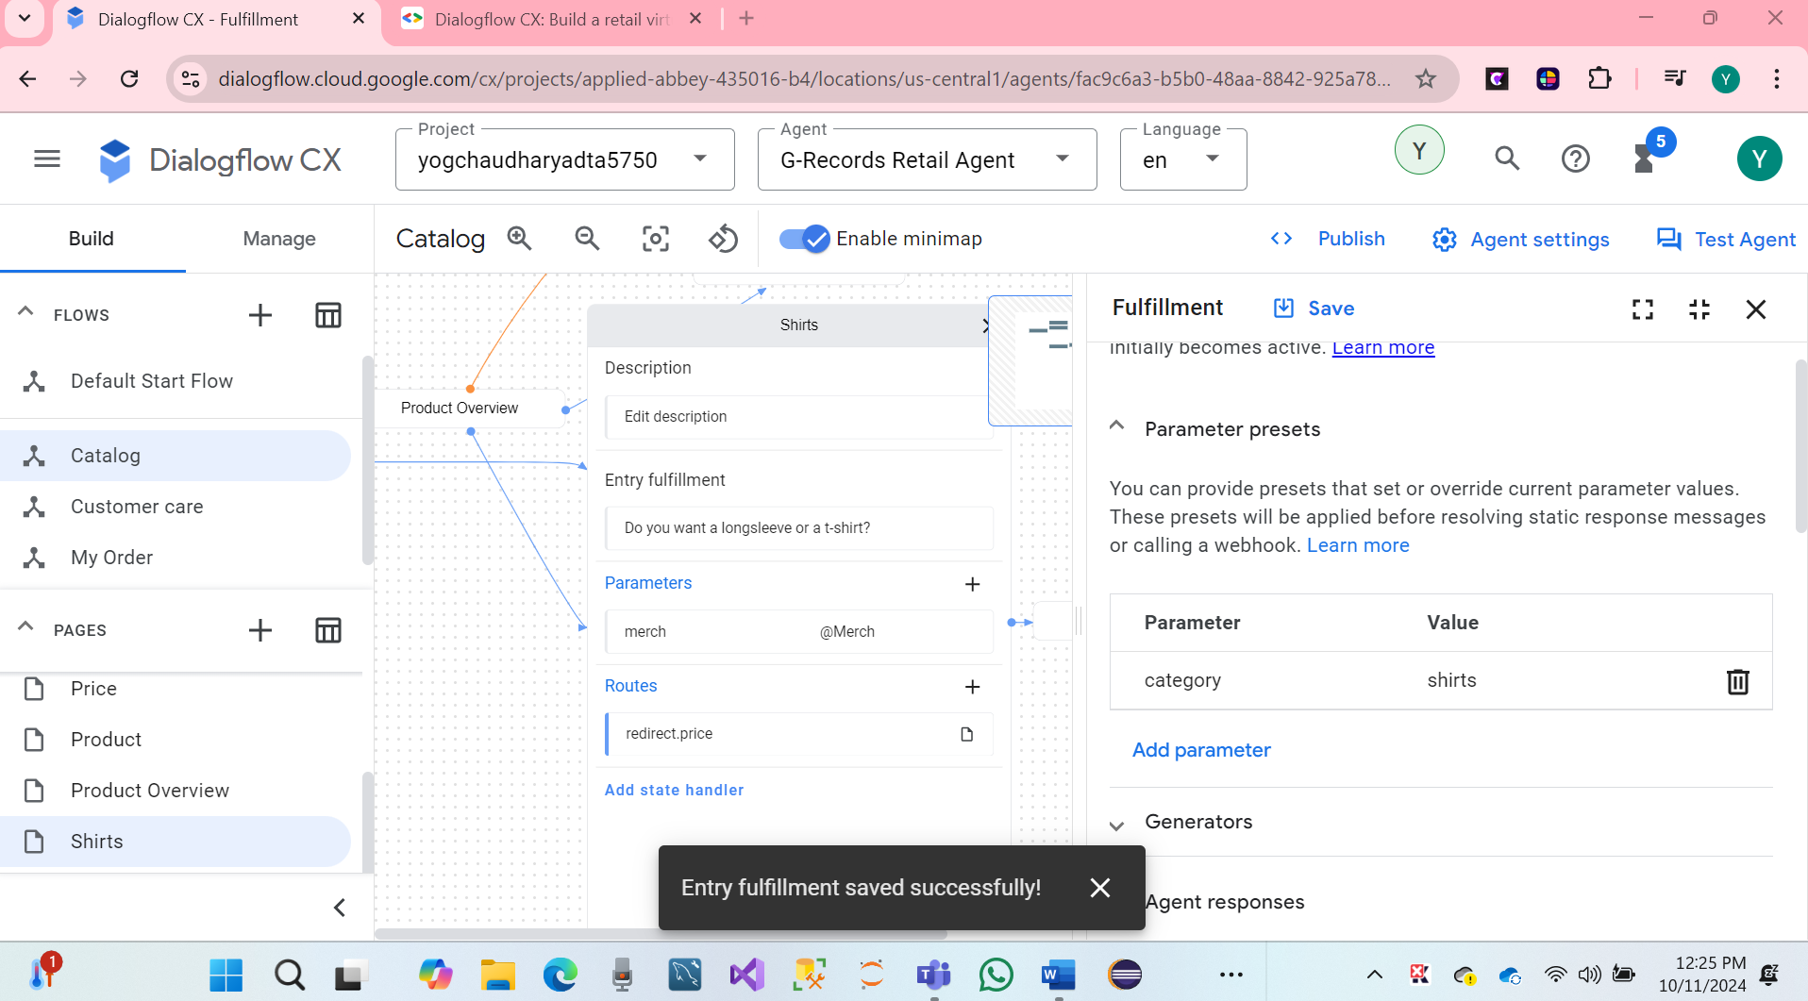

**Test Agent:**

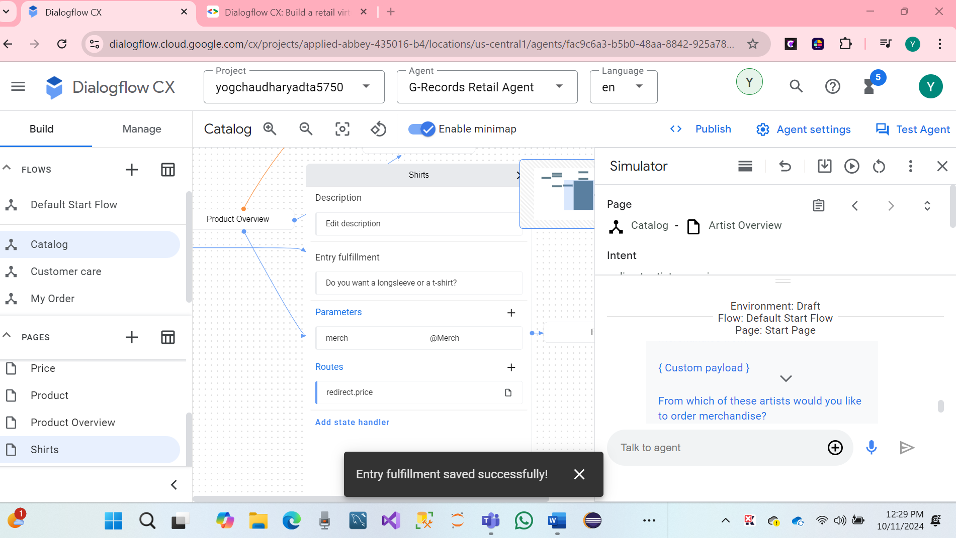

**Add a Conditional Route:**

* Match At Least One Rule (OR)
* Expression: $session.params.merch = "T-shirt"
* Expression: $session.params.merch = "Longsleeve"
* Transition to new page: Shirt Size
* **Price page**

1 Create the following configurations in the Price Page:

* Entry fulfillment: PRICE TODO

2 Add a conditional Route:

* Match Every rule (AND)
* Expression: $session.params.category = "shirts"
* Expression: $session.params.merch = "null"
* Transition to new page: Shirts

3 Add a Conditional Route:

* Match Every rule (AND)
* Expression: $session.params.category = "shirts"
* Expression: $session.params.size = "null"
* Transition to new page: Shirt Size

4 Add a Conditional Route:

* Match Every rule (AND)
* Expression: $session.params.category = "music"
* Expression: $session.params.album = "null"
* Transition to new page: Music

5 Add a Conditional Route:

* Match Every rule (AND)
* Expression: $session.params.category = "music"
* Expression: $session.params.merch = "null"
* Transition to new page: Carrier

6 Add a Conditional Route:

* Match Every rule (AND)
* Expression: $session.params.category = "null"
* Transition to new page: Product Overview

We have Create the following in the Shirt Size Page.

* Entry fulfillment: What shirt size do you want?
* Entry fulfillment Custom payload:

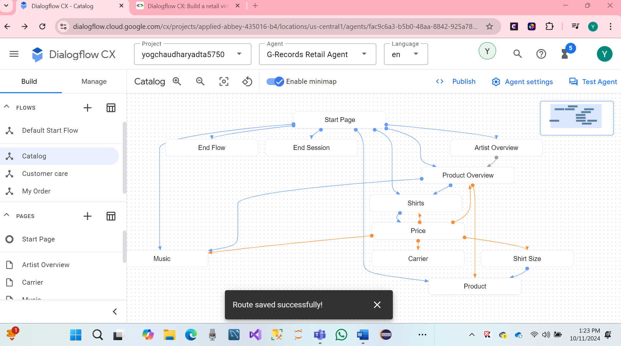

* **Music Page**

1 We have Create the following configurations in the Music Page:

* Entry fulfillment: We have a Greatest Hits Album or the Live Album. Which one do you want?
* Entry fulfillment Custom payload:

2 Create an Intent Route: redirect.price with a transition to Page: Price.

3 Create the following parameter:

* Parameter: album - Entity Type: @Album - Required, Redact In Log
* Parameter > Event Handler > No-match default
* Parameter > Event Handler Fulfillment: You can choose between Greatest Hits and Live Album. Which of these do you want?
* Parameter > Event Handler Fulfillment Custom payload

4. Click on the entry fulfillment and scroll down to **Parameter presets**, each time when the Music page gets active, the category parameter will be set to *music*:

* Parameter: category
* Value: Music
* Hare screenshot.

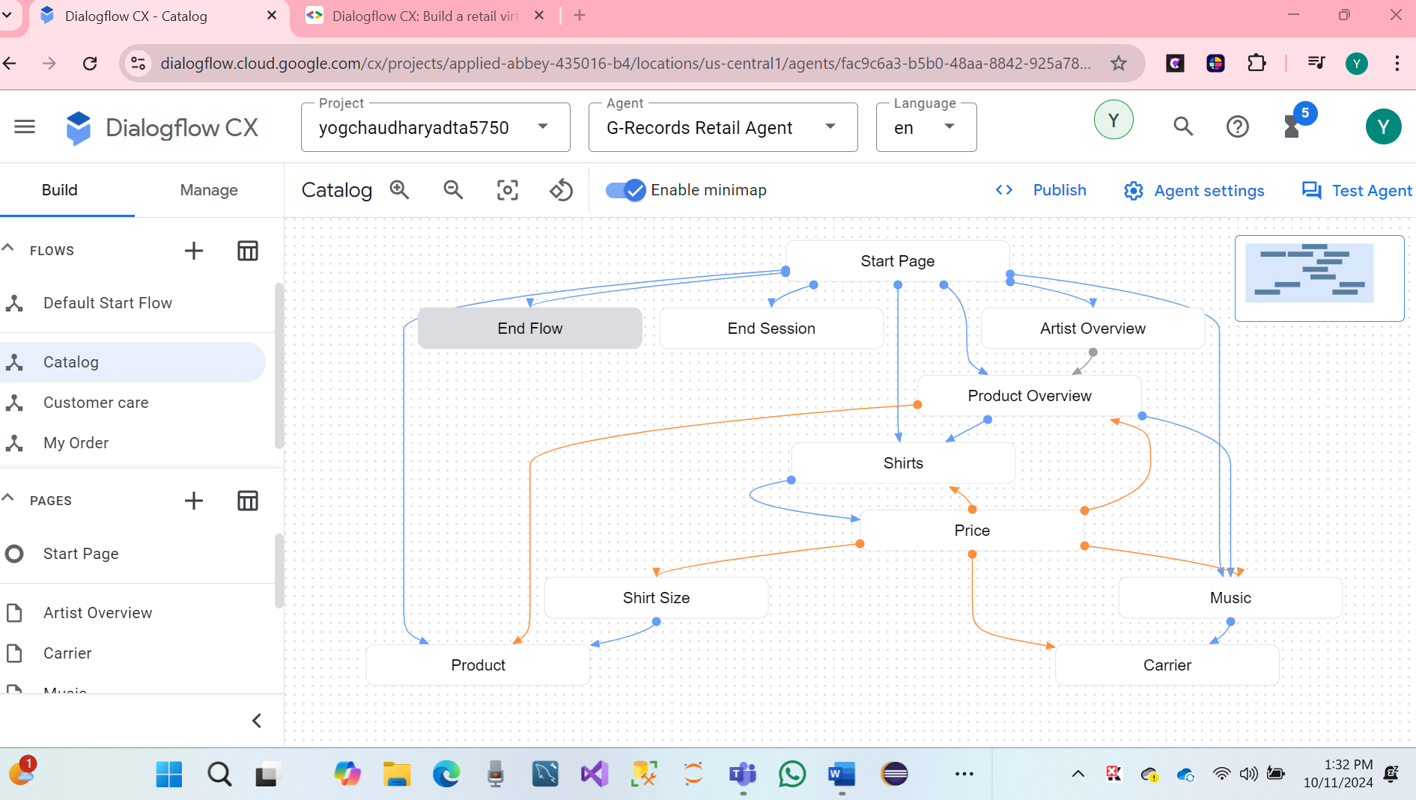

* **Carrier Page:**

1 Create the following configurations in the *Carrier* Page:

* Entry fulfillment: Do you want this album on CD or MP3?
* Entry fulfillment Custom payload:

2 Create an **Intent route**: redirect.price which transitions to the Price Page.

3 Create the following parameter:

* Parameter: merch - Entity Type: @Merch - Required, Redact In Log
* Parameter > Event Handler > No-match default
* Parameter > Event Handler Fulfillment: Do you want a physical CD or the digital album?
* Parameter > Event Handler Fulfillment: Custom payload:
* Parameter > Event Handler > No-input default
* Parameter > Event Handler Fulfillment: I couldn't understand if you mean CD or MP3. Which one do you want?
* Parameter > Event Handler Fulfillment: Custom payload

4. Add a Conditional Route:

* Match Every rule (AND)
* Expression: $page.params.merch != "null"
* Transition to Page: Product

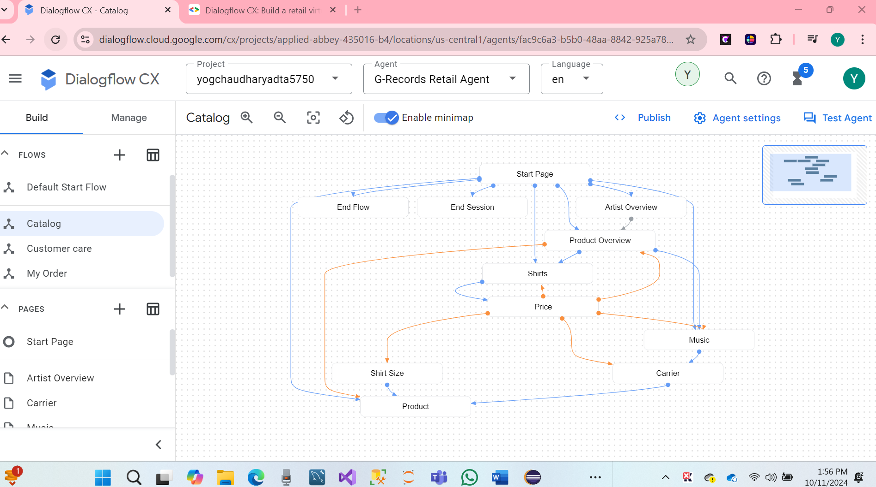

* **Product page.**

We have created the following product page.

|  |  |  |
| --- | --- | --- |
| **Parameter Displayname** | **Parameter Entity Type** | **Checks** |
| artist | @Artist | Required, Redact in log |
| merch | @Merch | Required, Redact in log |

2. The artist parameter needs the following initial prompt fulfillment, which will be shown when the artist isn't known. You didn't mention which artist you are interested in. we can ask me to buy the $session.params.merch of the artist you like or ask which artists we signed. How can I help?

* Also add a No-input default event handler with fulfillment: I couldn't understand what you just said. Ask me which artists are signed.

3. The *merch* parameter needs reprompt event handlers as well.

* Add a No-input default event handler with fulfillment: I couldn't understand what you just said. Which merchandise item do you want?
* And a No-match default event handler with fulfillment: I missed that. Which merchandise item do you want?

The next route will transition to the confirmation page when the artist is known and the user chooses a "Tour Movie".

4. Add a Conditional Route:

* Match Every rule (AND)
* Expression: $session.params.artist != null
* Expression: $session.params.merch = "Tour Movie"
* Parameter Presets Add Parameter > price = 25
* Transition to new page: Confirmation

5. Add a Conditional Route:

* Custom Expression: $session.params.artist != null AND $session.params.merch = "T-shirt" AND $session.params.shirtsize != null
* Parameter Presets Add Parameter > price = 25
* Transition to page: Confirmation

6. Add a Conditional Route:

* Custom Expression: $session.params.artist != null AND $session.params.merch = "Longsleeve" AND $session.params.shirtsize != null
* Parameter Presets Add Parameter > price = 30
* Transition to page: Confirmation

7. Add a Conditional Route:

* Custom Expression: $session.params.artist != null AND $session.params.merch = "CD" AND $session.params.album != null
* Parameter Presets Add Parameter > price = 15
* Transition to page: Confirmation

8. Add a Conditional Route:

* Custom Expression: $session.params.artist != null AND $session.params.merch = "Digital Album" AND $session.params.album != null
* Parameter Presets Add Parameter > price = 10
* Transition to page: Confirmation

9. Add a Conditional Route:

* Custom Expression: $session.params.artist != null AND ($session.params.merch = "CD" OR $session.params.merch = "Digital Album") AND $session.params.album = null
* Fulfillment: I would also need to know which album you would like to buy!
* Transition to page: Music

10. Add a conditional Route:

* Custom Expression: $session.params.artist != null AND ($session.params.merch = "T-shirt" OR $session.params.merch = "Longsleeve") AND $session.params.shirtsize = null
* Fulfillment: I would also need to know which shirt size you need!
* Transition to page: Shirt Size
* We can see screenshots.

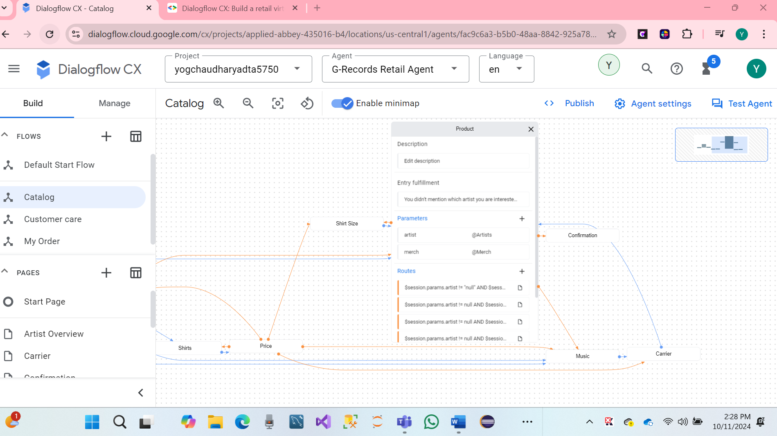

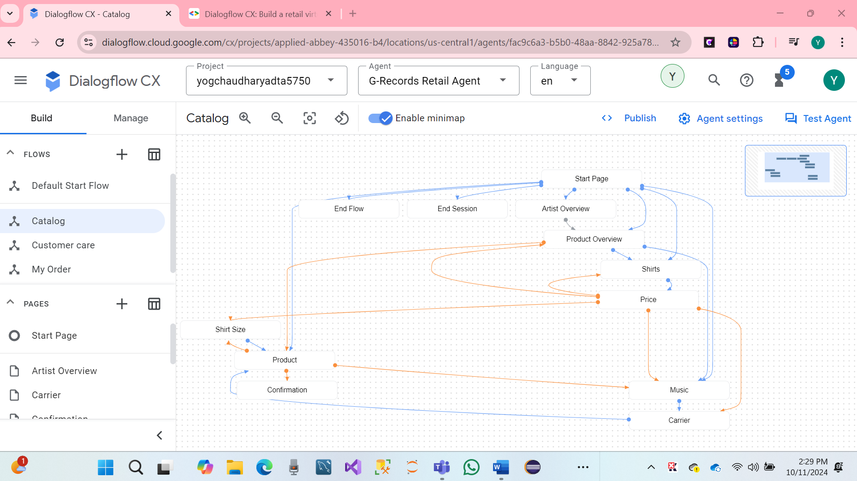

**TO-DO #3 Next, complete the steps to add conditional responses.**

1. Click on Conditional Responses
2. Click Edit Fulfillment > Agent Responses > **Add dialogue** option > **Conditional Response**:

if ($session.params.merch = "CD" OR $session.params.merch = "Digital Album")  
  The $session.params.merch: $session.params.artist - $session.params.album costs $$session.params.price. Shall I continue to order?  
elif ($session.params.merch = "T-shirt" OR $session.params.merch = "Longsleeve")  
  A $session.params.merch of $session.params.artist size: $session.params.shirtsize costs $$session.params.price. Shall I continue to order?  
elif $session.params.merch = "Tour Movie"  
  The $session.params.merch of $session.params.artist costs $$session.params.price. Shall I continue to order?  
else  
  It looks like something went wrong with your order. You can say "Reset", to restart the order process.  
endif

* Create the following Custom payload:
* Custom payload:
* Next, create two intent routes:

1. confirm.proceed.order transitions to: Order Process Flow.
2. decline.proceed.order transitions to End Flow
3. In the **decline.proceed.order** intent, scroll down to **Parameter presets** and add the following parameters:

|  |  |
| --- | --- |
| Parameter | value |
| Artist | Null |
| Merch | Null |
| Shirtsize | Null |
| Category | Null |
| Album | Null |
| Price | Null |
| restart | Null |

1. Click on the **Default Start Flow**, **Start** Page, and create another *Conditional Route*:

* $session.params.restart = "true"
* Fulfillment: "Welcome back, as the virtual agent of G-Records, I can help you order artists merchandise, you can ask questions about your order or shipping, and I can tell you more which artists are currently signed with us. How can I help?"
* Custom payload:

1. Select the **Start** Page and click on the redirect.end intent. Create the following fulfillment: Thank you for contacting G-Records! Have a nice day!

* **Price Page**

Click on the Price Page in the Catalog Flow, and use the following entry fulfillment:

* Delete the Agent Says entry fulfillment.
* Create a new Conditional Response:

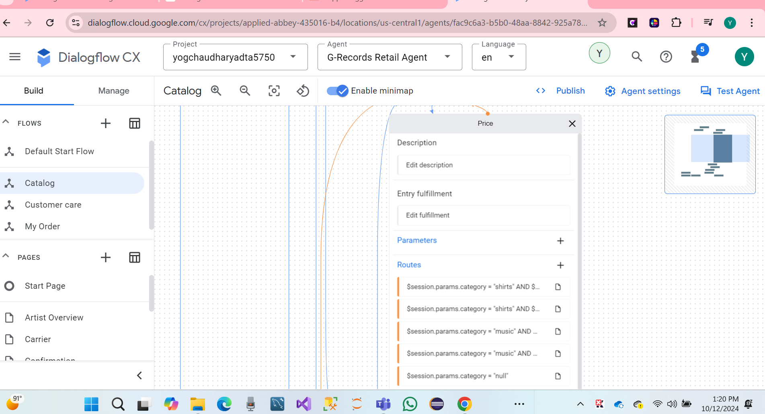

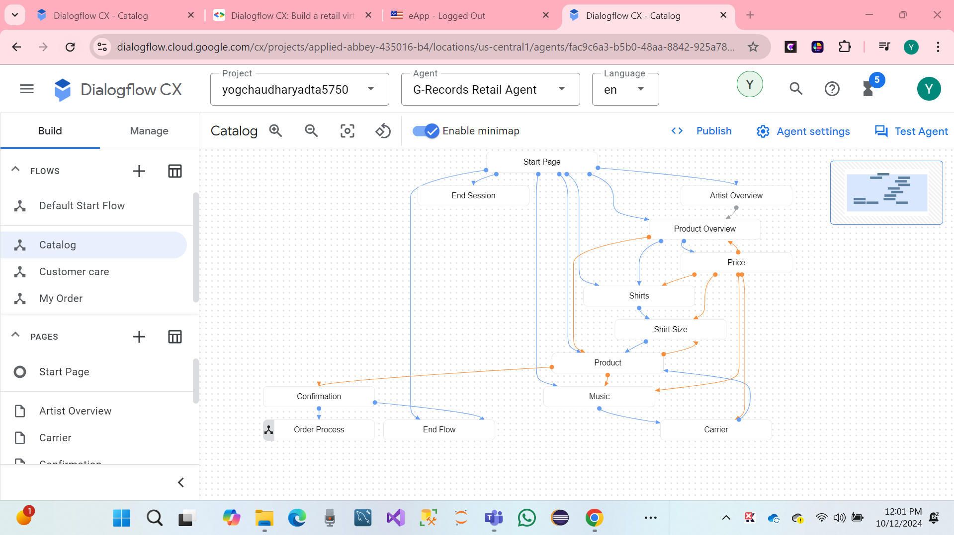

Finally, successfully condition responses.

**TO-DO #4 Next, complete the steps to wrap up the virtual retail agent.**

1. We have created the My Order Flow with the following intent for the Wrapping up the agent.

|  |  |  |
| --- | --- | --- |
| **Page (In Flow)** | **Routes > Intent** | **Routes > Transition To** |
| My Order Start | redirect.my.order | My Order |
| My Order Start | redirect.my.order.status | My Order Status |
| My Order Start | redirect.my.order.canceled | My Order Cancellation |
| My Order Start | redirect.end | End Session |
| My Order Start | redirect.home | End Flow |
| My Order Start | redirect.my.order.canceled | Flow: My Order |
| My Order Start | redirect.my.order.status | Flow: My Order |

1. Let's create the following entry fulfillment for the My Order Page:

* Entry fulfillment: I can look up the status of your order, or I can cancel an order.

1. In the My Order Page create the following parameter:

* Displayname: ordernumber
* Entity Type: @OrderNumber
* Required: checked
* Initial prompt fulfillment: What's the order number? For example, ABCD123.

**Event Handler:** No-match default: To proceed with your order I will need an order number. Order numbers start with 4 characters and end with 3 numbers, such as ABCD123. Which order number may I use?

**Event Handler:** No-input default: I missed that. To proceed with your order I will need an order number. Order numbers start with 4 characters and end with 3 numbers, such as ABCD123. Which order number may I use?

1. Create the following conditional route:

* Customize Expression: $page.params.status = "FINAL"
* Fulfillment: And do you want to Cancel your order, or should I look up the status?

1. Click on Add state handler > Event Handlers and create the Event Handler: No-input default

* Fulfillment: I'm sorry, what was that? Would you like me to cancel an order or look up the status?
* Custom payload:

1. Create the Event Handler: No-match default

* Fulfillment: Would you like me to cancel an order or lookup the status?
* Custom payload:

1. In the **My Order Status** Page create the following parameter:

* Displayname: ordernumber
* Entity Type: @OrderNumber
* Required checked
* Initial prompt fulfillment: What's the order number? For example ABCD123.

Event Handler: No-match default: To proceed with your order I will need an order number. Order numbers start with 4 characters and end with 3 numbers, such as ABCD123. Which order number may I use?

Event Handler: No-input default: I missed that. To proceed with your order I will need an order number. Order numbers start with 4 characters and end with 3 numbers, such as ABCD123. Which order number may I use?

1. In the My Order Status Page create the following conditional route:

* Customize Expression: $session.params.ordernumber != null
* Fulfillment: Your order $session.params.ordernumber has been shipped, it can take up to approx 2 weeks before you will receive your items.
* Add dialogue option > Text: Is there anything else I can help you with?

1. In the My Order Cancelation Page create the following parameter:

* Displayname: ordernumber
* Entity Type: @OrderNumber
* Required checked
* Initial prompt fulfillment: What's the order number? For example ABCD123.

Event Handler: No-match default: To proceed with your order I will need an order number. Order numbers start with 4 characters and end with 3 numbers, such as ABCD123. Which order number may I use?

Event Handler: No-input default: I missed that. To proceed with your order I will need an order number. Order numbers start with 4 characters and end with 3 numbers, such as ABCD123. Which order number may I use?

1. In the My Order Cancelation Page create the following conditional route:

* Customize Expression: $session.params.ordernumber != null
* Fulfillment: Your order $session.params.ordernumber has been canceled.
* Add dialogue option > Text: Is there anything else I can help you with?

1. Test the flow and create the following two test scenarios.

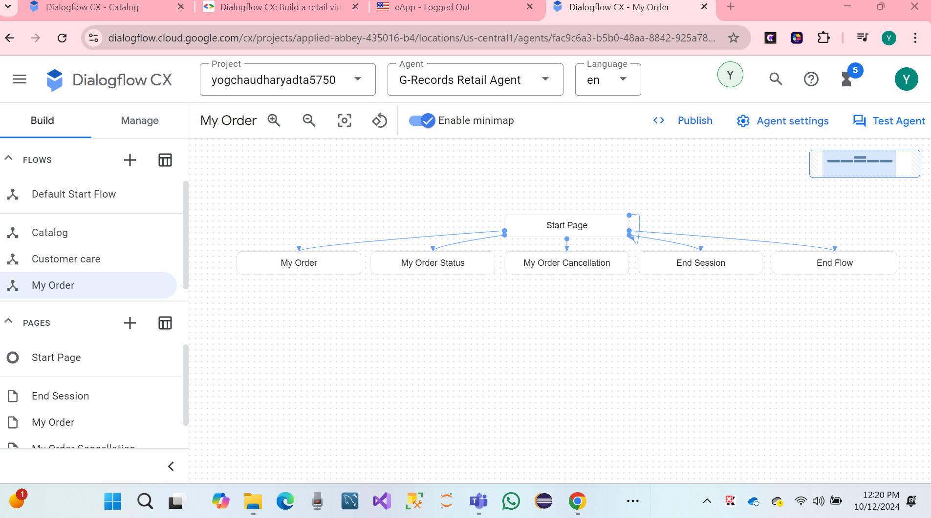

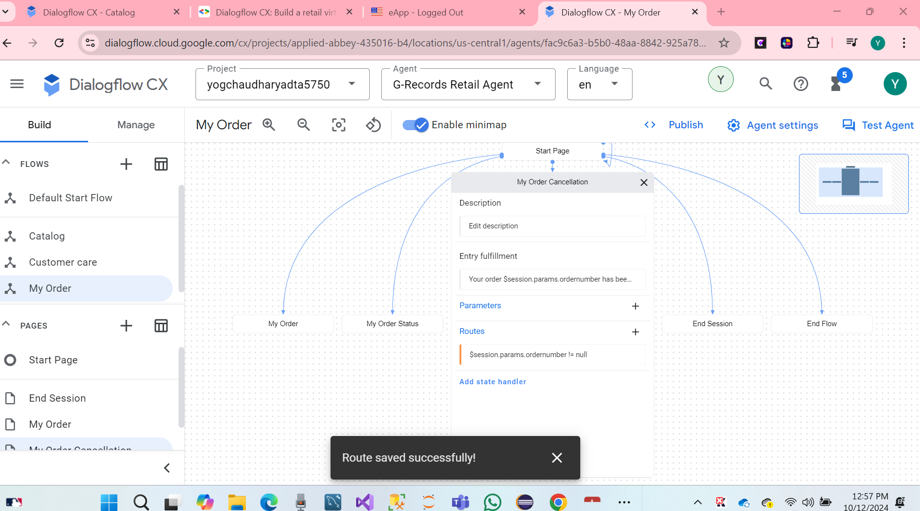

* **Default Negative intents (Fallback)**

We have managed to create new intents, selected Default Negative Intent. We can add training phrases to these intents that act as negative. There is access where end-user inputs have a slight resemblance to training phrases in normal intents, by, we can do nor want their inputs to matcha any normal intents.

* Click hit save.

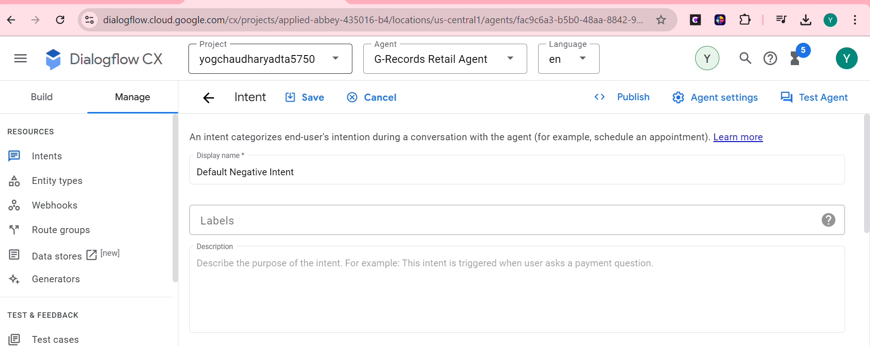

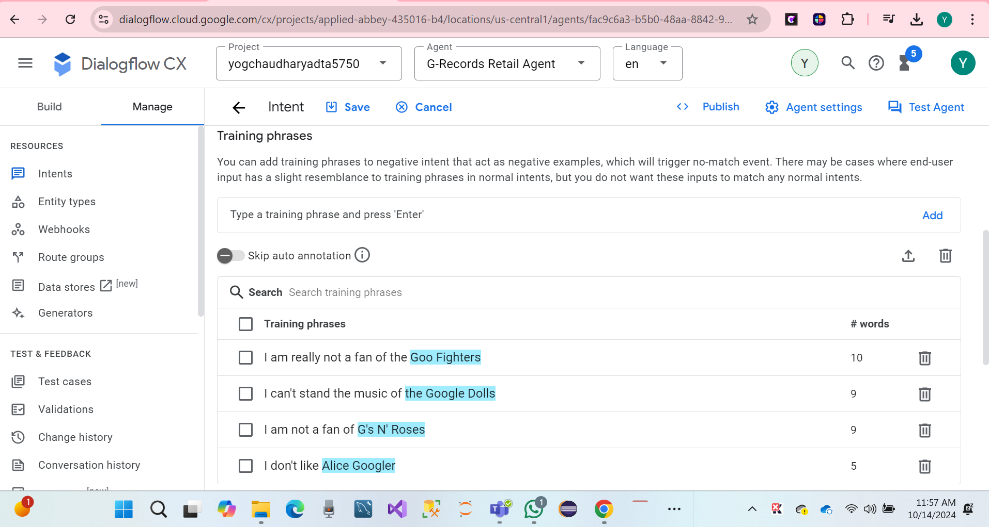

* **Creating the Order process Flow.** 
  1. Go to the Order Process Flow, and create the following intent transitions

|  |  |  |
| --- | --- | --- |
| **Page (In Flow)** | **Routes > Intent** | **Routes > Transition To** |
| Order Process Start | redirect.end | End Session |
| Order Process Start | redirect.home | End Flow |
| Order Process Start | confirm.proceed.order | New Page: Shipping Details |

* 1. Let's create the following entry fulfillment for the Shipping Details Page:
* Entry fulfillment: To complete your order I will first need to collect your shipping details.
  1. Create the following parameters:

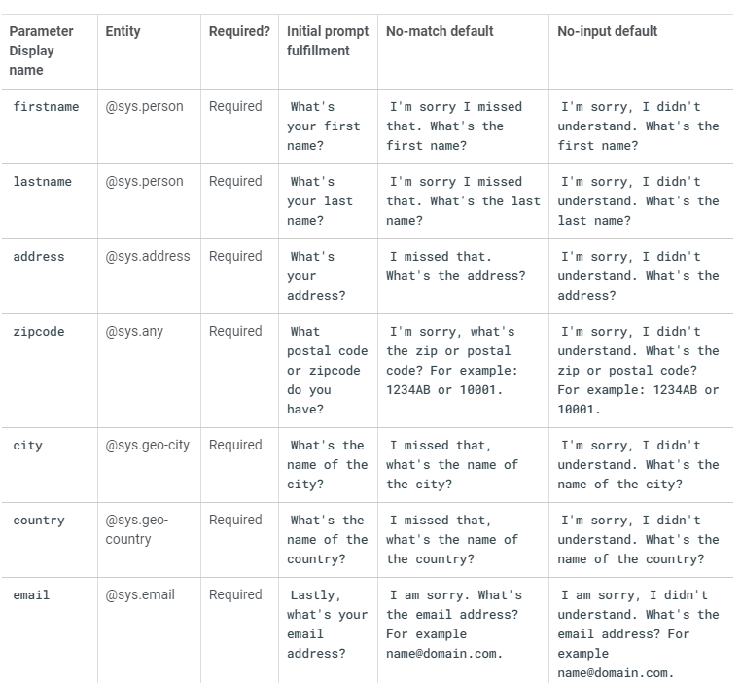

* 1. Create the following conditional route:
* Customize Expression: $page.params.status = "FINAL"
* Transition to new Page: Payment Details
  1. Create the following entry fulfillment.
* Agents Says:
* Alright $session.params.firstname! We will make use of Google Pay, that's connected to your email account: $session.params.email.
* Conditional Response
* if $session.params.merch != "Digital Album"  
    Shipping costs an additional 5 dollars. This will make the total price $$sys.func.TO_TEXT($sys.func.ADD($session.params.price, 5)).  
    Your merchandise will be shipped to:  
    $session.params.firstname $session.params.lastname  
    $session.params.address  
    $session.params.zipcode $session.params.city  
    $session.params.country  
    To continue the order process please explicitly say "I confirm". Do you want to confirm your $session.params.artist $session.params.merch order?  
  else  
    The total costs will be: $$session.params.price.  
    After purchasing the digital album, you will receive an email with the download link.  
    To continue the order process please explicitly say "I confirm".  
    Do you want to confirm your $session.params.artist $session.params.merch order?  
  endif

1. Create the following Intent Route

* Intent: confirm.proceed.order
* Agent Says: Thank you for your order! Your merchandise will be shipped today!
* Add Dialogue Option > Text: Here's the order number: ABCD123.
* Add Dialogue Option > Text: Have a good day!
* Transition: End Session

1. Select the Start Page and click on the redirect.end intent. Create the following fulfillment: Thank you for contacting G-Records! Have a nice day!
2. Select the Start Page and click on the redirect.home intent. Create the following parameter preset: restart = true

* Hare Screenshot.

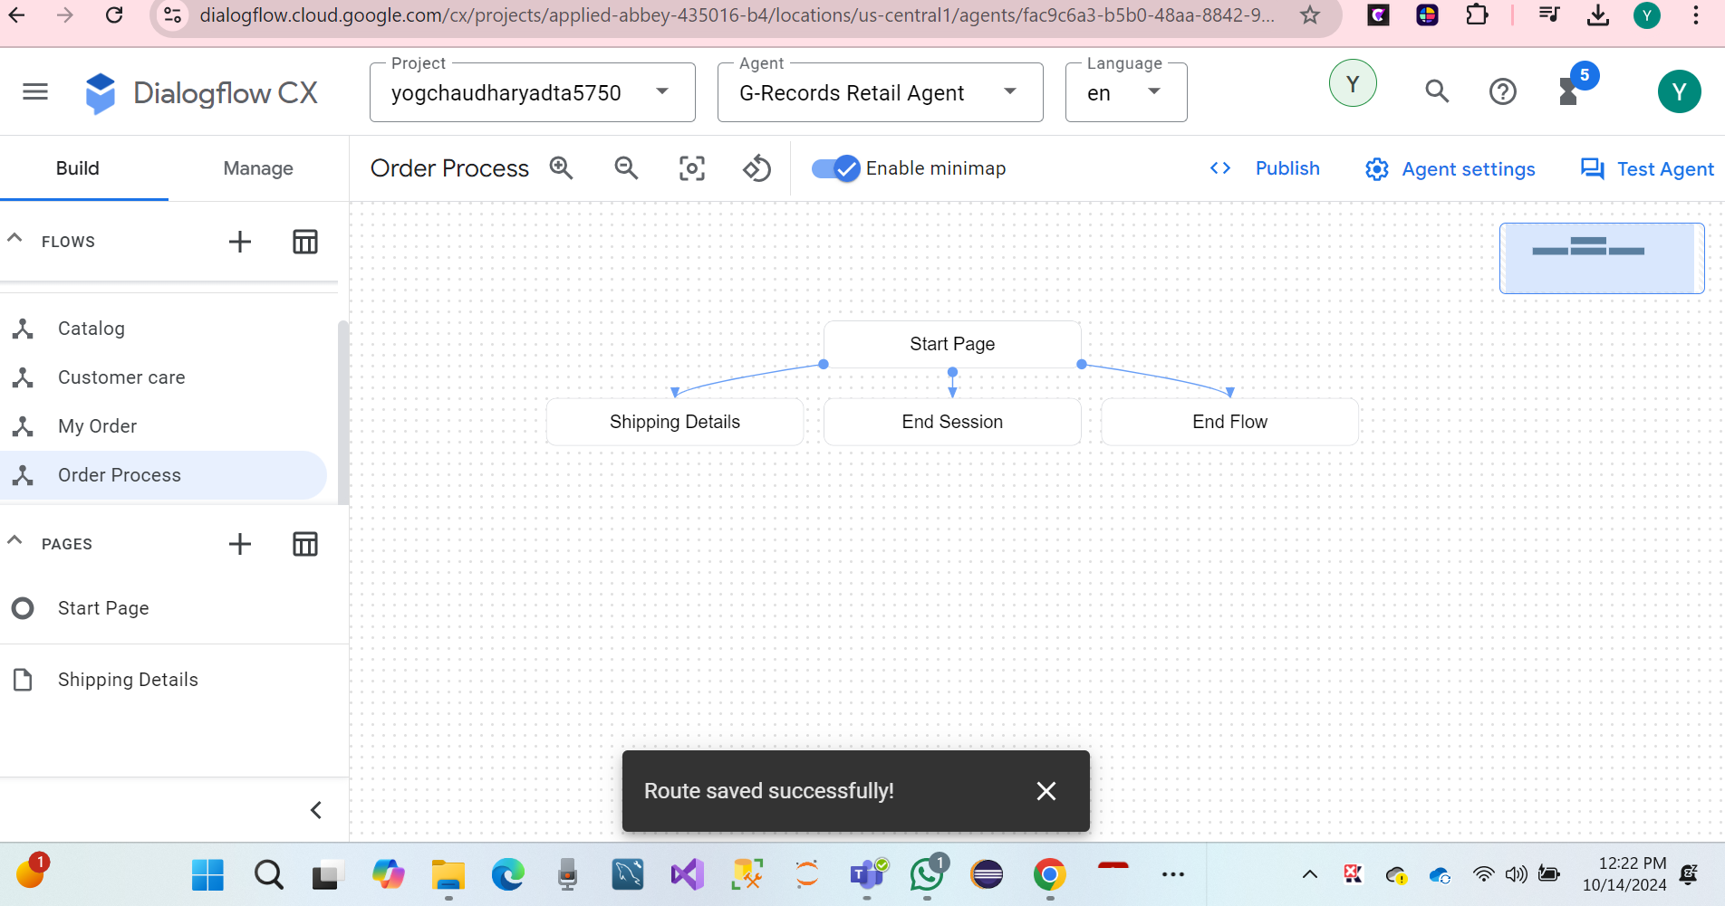

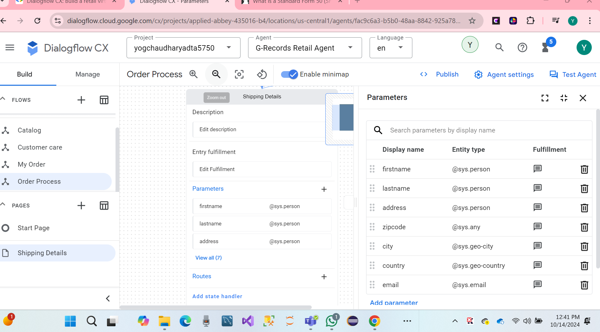

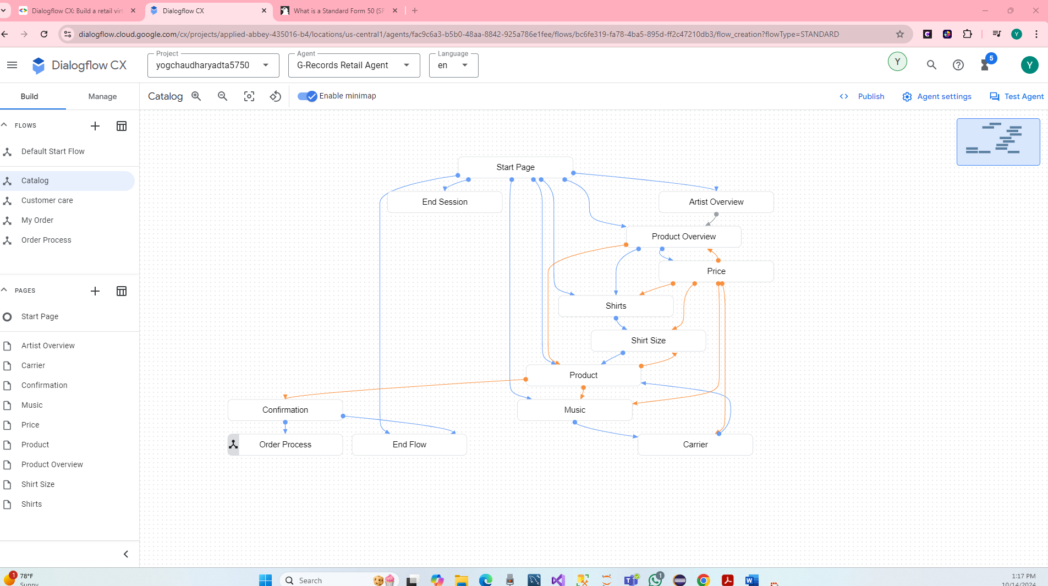

**TO-DO #5** Finally, complete the steps to test the virtual retail agent.

* **Test your Virtual Agents:**

We have created the Customer Care flow.

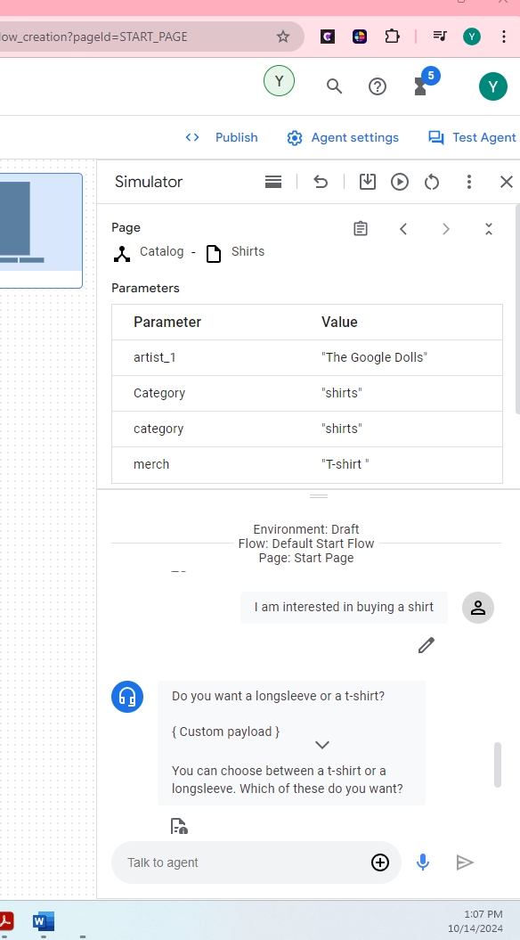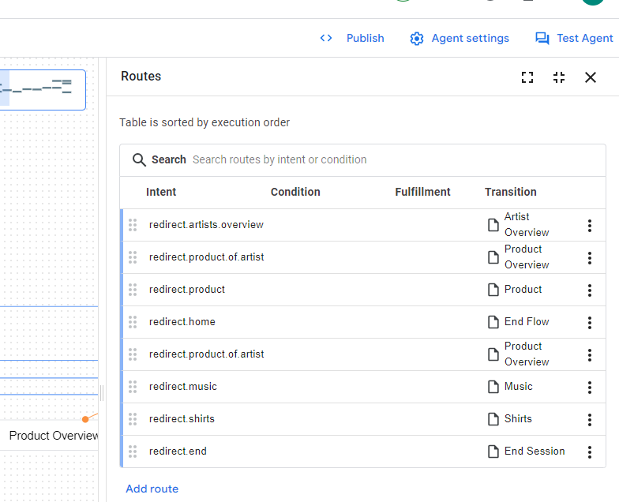

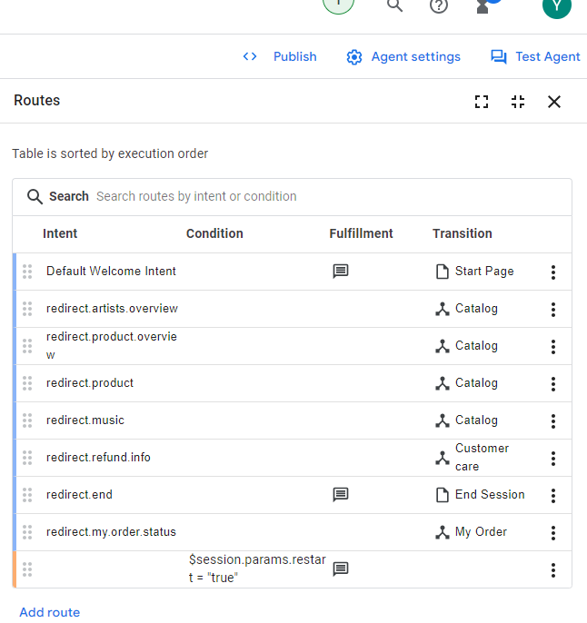 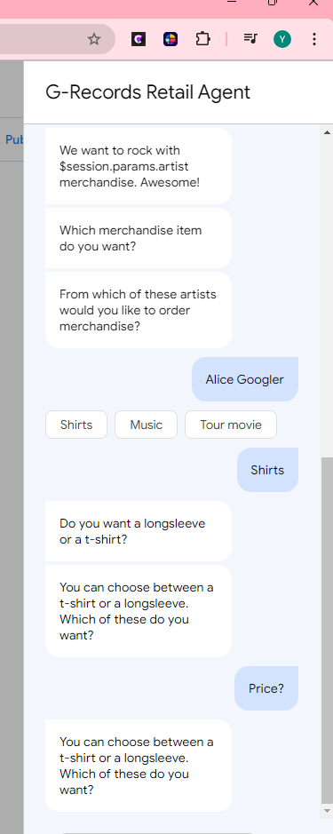

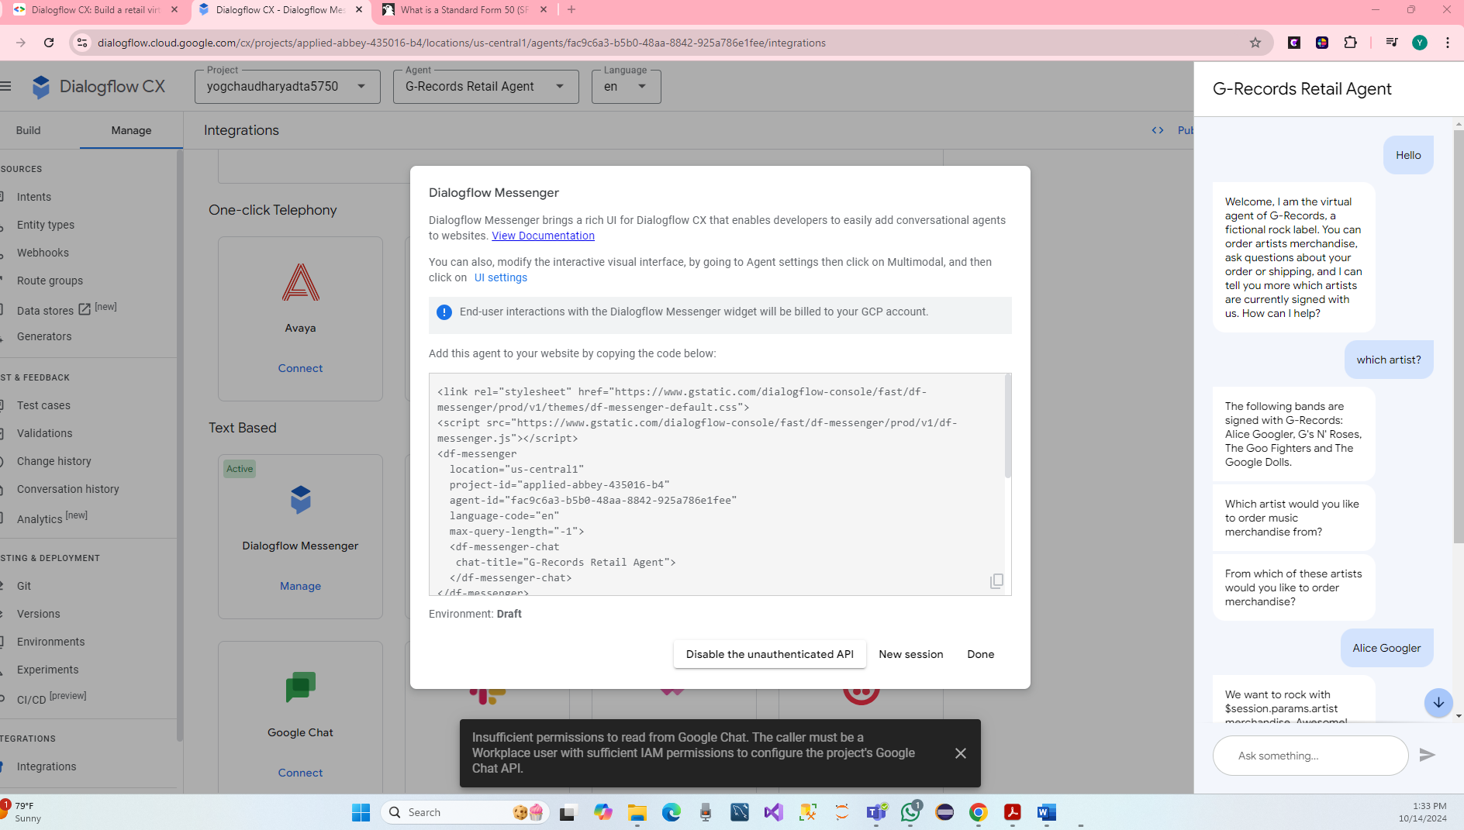

**TO-DO #6 While working on each TO-DO of PART II, capture the screenshots of each step.**

* **Conclusion.**

We have done Dialogflow CX is a Conversational AI Platform (CAIP) for creating virtual agents like chat or voice bots. We have been creating enterprise level conversation in the virtual Agents for G-Record.

We addressing the following concepts as for details.

* Flows
* Parameters, Custom & System Entities
* Pages
* State Handlers like Intent Routes and Condition Routes
* Static Fulfillment Messages and Conditional Responses
* Fallback intents
* Simulator, Test Cases and Coverage
* Hare Screenshots.

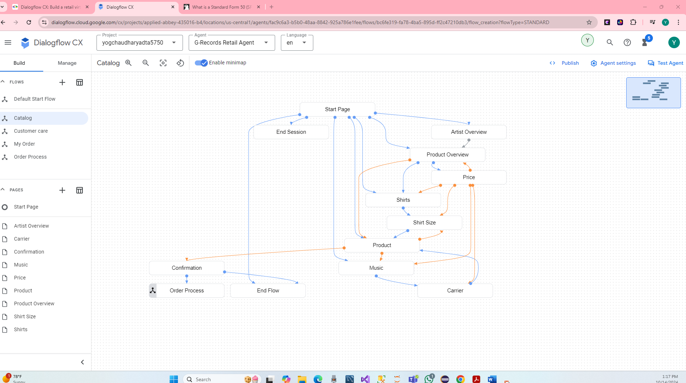

**References**

To learn more about Dialogflow CX have a look at the following blogs and documentation.

* Dialogflow CX Technical Guides
* Dialogflow CX API Reference
* Dialogflow CX Components built by the community
* Dialogflow blog by Conversational AI developer advocate Lee Boonstra

<https://codelabs.developers.google.com/codelabs/dialogflow-cx-retail-agent#9>

<https://www.youtube.com/watch?v=bpzSQTZ9MzI>

<https://www.youtube.com/watch?v=PGOWuHhi0Mg>

<https://en.wikipedia.org/wiki/Finite-state_machine>

<https://cloud.google.com/dialogflow/cx/docs/concept/page?utm_source=codelabs&utm_medium=et&utm_campaign=CDR_lee_aiml_leedialogflowlabs_cx_&utm_content=->

<https://cloud.google.com/dialogflow/cx/docs/concept/flow?utm_source=codelabs&utm_medium=et&utm_campaign=CDR_lee_aiml_leedialogflowlabs_cx_&utm_content=->